ENVIRONMENTAL LAWS
Governing Sustainability in India
A Comprehensive Guide to India's Environmental Legal Framework
2026 Edition

Table of Contents
This ebook contains the following chapters:
- 1. Executive Summary
- 2. Chapter 1: Constitutional Framework
- 3. Chapter 2: Core Environmental Legislation
- 4. Chapter 3: Sectoral Environmental Regulations
- 5. Chapter 4: Environmental Impact Assessment
- 6. Chapter 5: Waste Management Framework
- 7. Chapter 6: Climate Change and Renewable Energy
- 8. Chapter 7: Judicial Interpretation and Public Interest Litigation
- 9. Chapter 8: Emerging Environmental Challenges
- 10. Chapter 9: International Environmental Obligations
- 11. Chapter 10: Institutional Framework and Governance
- 12. Conclusion
- 13. References and Further Reading

Executive Summary
India's environmental legal framework represents one of the most comprehensive systems in the developing world, encompassing constitutional provisions, statutory laws, regulatory mechanisms, and judicial interpretations that collectively govern environmental sustainability. This ebook provides an exhaustive analysis of the legal architecture that shapes environmental governance in India, from foundational constitutional articles to contemporary regulatory instruments addressing climate change, biodiversity conservation, pollution control, and sustainable development.
The Indian Constitution, through Articles 48A and 51A(g), establishes the fundamental duty of the state and citizens to protect and improve the environment. This constitutional mandate has been reinforced through landmark judicial pronouncements that have recognized environmental rights as fundamental rights under Article 21, which guarantees the right to life. The judiciary has played a transformative role through the doctrine of public interest litigation (PIL), enabling environmental activism and enforcement.
India's statutory framework includes over 200 environmental laws and regulations covering air quality, water resources, forests, wildlife, coastal zones, hazardous substances, and waste management. The Environment (Protection) Act, 1986 serves as the umbrella legislation, providing the central government with comprehensive powers to coordinate environmental protection activities. Sectoral laws such as the Water (Prevention and Control of Pollution) Act, 1974, the Air (Prevention and Control of Pollution) Act, 1981, and the Forest (Conservation) Act, 1980 establish specialized regulatory regimes.
The journey from reactive pollution control to proactive environmental management reflects growing environmental consciousness and India's commitment to sustainable development. Recent initiatives including the National Action Plan on Climate Change, National Clean Air Programme, and ambitious renewable energy targets demonstrate India's leadership in addressing global environmental challenges while pursuing economic development objectives.

Chapter 1: Constitutional Framework

1.1 Constitutional Provisions
The Indian Constitution, adopted in 1950, was one of the first constitutions globally to incorporate environmental concerns, though these were initially framed within the broader context of social welfare and public health. The 42nd Amendment Act of 1976 marked a watershed moment by explicitly introducing environmental protection as a constitutional obligation. This amendment inserted Article 48A in the Directive Principles of State Policy and Article 51A(g) in the Fundamental Duties chapter, creating a dual obligation framework.

Article 48A: Directive Principles
Article 48A mandates: 'The State shall endeavour to protect and improve the environment and to safeguard the forests and wildlife of the country.' This provision transforms environmental protection from a discretionary policy consideration into a constitutional directive. Although Directive Principles are not enforceable by courts, they serve as fundamental guidelines for governance and have been consistently invoked by the judiciary to interpret and expand environmental rights.
The placement of environmental protection within the Directive Principles alongside economic and social justice provisions reflects the framers' understanding of environmental sustainability as integral to comprehensive development. This constitutional architecture has enabled courts to harmonize environmental protection with development objectives, giving rise to the doctrine of sustainable development in Indian jurisprudence.

Article 51A(g): Fundamental Duties
Article 51A(g) declares: 'It shall be the duty of every citizen of India to protect and improve the natural environment including forests, lakes, rivers and wildlife, and to have compassion for living creatures.' This provision democratizes environmental responsibility, extending it beyond state institutions to individual citizens. The inclusion of 'compassion for living creatures' reflects indigenous Indian philosophical traditions that emphasize harmony between humans and nature.

Article 21: Right to Life and Environment
The Supreme Court of India has expansively interpreted Article 21, which guarantees the right to life and personal liberty, to encompass the right to a healthy environment. In landmark judgments such as Rural Litigation and Entitlement Kendra v. State of Uttar Pradesh (1985), the Court held that the right to life includes the right to live in a wholesome environment. Subsequent decisions have established that environmental degradation affecting public health constitutes a violation of fundamental rights, thereby making environmental protection justiciable and enforceable.

1.2 Distribution of Legislative Powers
The Seventh Schedule of the Constitution delineates legislative competence between the Union and State governments through three lists: Union List, State List, and Concurrent List. Environmental subjects are distributed across these lists, creating a complex federal structure for environmental governance. Entry 17 of the State List covers forests, Entry 6 covers public health, and several entries in the Concurrent List address environmental matters.
The 42nd Amendment added Entries 17A and 17B to the Concurrent List, specifically addressing forests and protection of wild animals and birds. This shift reflected growing recognition that environmental problems transcend state boundaries and require coordinated national-level intervention. The concurrent jurisdiction enables both central and state legislation, with central laws prevailing in case of conflict. This framework has enabled comprehensive national environmental laws while preserving state autonomy in implementation and adaptation to local conditions.

Key Environmental Indicators in India
The following table presents critical environmental statistics that underscore the importance of robust legal frameworks:
Indicator | Value | Legal Framework
Forest Cover | 24.62% of total area | Forest Conservation Act, 1980
Protected Areas | 870+ (5% of area) | Wildlife Protection Act, 1972
Renewable Energy | 175 GW target by 2022 | National Action Plan on Climate Change
Air Quality Monitoring | 800+ stations | Air (Prevention & Control) Act, 1981
Environmental Clearances | 2000+ annually | EIA Notification, 2006
Wetland Sites (Ramsar) | 75 sites | Wetlands Rules, 2017

Chapter 2: Core Environmental Legislation

2.1 Environment (Protection) Act, 1986
The Environment (Protection) Act, 1986 represents India's most comprehensive environmental legislation, enacted in response to the Bhopal gas tragedy of 1984. This umbrella statute empowers the central government to take measures for protecting and improving environmental quality, controlling pollution, and establishing environmental standards. The Act was passed to fulfill India's obligations arising from the Stockholm Conference on Human Environment of 1972.
Section 3 of the EPA grants sweeping powers to the central government to take all necessary measures for environmental protection. These powers include establishing environmental quality standards, restricting areas for industrial operations, inspecting premises, directing closure or prohibition of industrial processes, and regulating hazardous substances. The Act applies to the entire country and overrides inconsistent state legislation, establishing a hierarchical regulatory framework.

Key Provisions and Powers
The Act defines 'environment' expansively to include water, air, land, and the interrelationship between these elements with human beings and other living creatures. This holistic definition enables comprehensive regulation of environmental impacts. Section 6 empowers the government to make rules for regulating environmental pollutants, establishing standards for emissions and discharges, safeguarding public health and welfare, protecting natural resources, and preventing environmental degradation.
The penal provisions under Section 15 prescribe imprisonment up to five years and fines up to one lakh rupees, with additional daily fines for continuing violations. Section 19 provides for offenses by companies, making directors and officers personally liable unless they can prove due diligence. The Act also establishes civil liability, empowering courts to direct violators to pay compensation to affected persons, independent of criminal prosecution.

2.2 Water (Prevention and Control of Pollution) Act, 1974
India's first comprehensive pollution control statute, the Water Act established institutional mechanisms for preventing and controlling water pollution. The Act created Central and State Pollution Control Boards with extensive regulatory, monitoring, and enforcement powers. The legislation recognizes that water pollution is primarily a regional problem requiring state-level intervention, while establishing national coordination mechanisms.
The Central Pollution Control Board (CPCB), established under Section 3, coordinates national water pollution programs, advises the government on policy matters, conducts research, and collects data on water quality. State Pollution Control Boards (SPCBs) exercise operational control, inspecting industrial plants, analyzing water samples, issuing consent orders, and enforcing compliance. This two-tier structure enables policy coherence while respecting federal principles.

Consent Mechanism
Sections 25 and 26 establish a prior consent system requiring industries to obtain approval before establishing operations or discharging effluents. The consent-to-establish precedes construction, while consent-to-operate enables actual discharge. SPCBs evaluate applications based on effluent quality standards, disposal methods, and potential environmental impacts. Consent orders specify conditions including treatment requirements, monitoring protocols, and reporting obligations.
The Act prohibits discharge of pollutants exceeding prescribed standards into water bodies. Section 43 empowers Boards to issue directions requiring industries to install treatment facilities, modify processes, or cease operations. Non-compliance attracts imprisonment up to six years and substantial fines. The Amendment Act of 1988 enhanced penalties and introduced stricter enforcement provisions, reflecting growing concern about industrial water pollution.

2.3 Air (Prevention and Control of Pollution) Act, 1981
Modeled on the Water Act, the Air Act extends pollution control to atmospheric emissions. The statute emerged from recognition that air pollution poses severe public health risks, particularly in urban and industrial areas. The Act empowers existing Pollution Control Boards with additional responsibilities for air quality management, avoiding institutional duplication while enabling comprehensive environmental regulation.
Section 19 prohibits operating industrial plants in pollution control areas without consent from State Boards. The consent mechanism mirrors the Water Act, requiring approval for establishing and operating facilities. Boards evaluate applications based on National Ambient Air Quality Standards (NAAQS), emission norms, and technological feasibility. The Act classifies areas based on pollution levels, enabling differentiated regulation with stricter controls in heavily polluted zones.

Air Quality Standards and Monitoring
The CPCB has notified ambient air quality standards for various pollutants including particulate matter (PM10, PM2.5), sulfur dioxide, nitrogen dioxide, carbon monoxide, ozone, lead, ammonia, and benzene. Standards specify concentration limits for industrial, residential, rural, and ecologically sensitive areas. The National Air Quality Monitoring Programme operates over 800 stations across 344 cities, generating real-time data for enforcement and policy interventions. State Boards conduct source-specific monitoring of industrial emissions, vehicular pollution, and construction activities.

Timeline of Major Environmental Legislation
India's environmental legal framework has evolved progressively over five decades:
Year | Legislation | Key Features
1972 | Wildlife Protection Act | Protection of wildlife, establishment of protected areas, regulation of hunting and trade
1974 | Water Act | Pollution Control Boards, consent mechanism, water quality standards
1980 | Forest Conservation Act | Prior approval for forest diversion, compensatory afforestation, forest protection
1981 | Air Act | Air quality standards, emission norms, pollution control areas
1986 | Environment Protection Act | Umbrella legislation, comprehensive powers, environmental standards, hazardous substances
2002 | Biological Diversity Act | Conservation of biodiversity, sustainable use, benefit sharing, access regulations
2010 | National Green Tribunal Act | Specialized environmental court, expedited proceedings, compensation for damages
2016 | Solid Waste Management Rules | Extended producer responsibility, waste segregation, recycling mandates
2019 | CRZ Notification | Coastal zone protection, marine conservation, regulated development

Chapter 3: Sectoral Environmental Regulations

3.1 Forest Conservation Act, 1980
The Forest (Conservation) Act, 1980 represents a paradigm shift in forest governance, restricting state autonomy over forest lands and centralizing approval for forest diversion. Enacted to arrest rapid deforestation for development projects, the Act prohibits state governments from dereserving forest lands or permitting non-forestry use without central government approval. This legislative intervention addressed the alarming depletion of forest cover that occurred during the 1970s.
Section 2 mandates prior central approval for diverting forest land for non-forest purposes, including mining, infrastructure projects, and agricultural expansion. The approval process involves multiple stages including preliminary screening, field inspections, impact assessment, and consideration by the Forest Advisory Committee. The Act applies to all forests irrespective of ownership or classification, establishing uniform conservation standards across government and private forest lands.

Compensatory Afforestation
The compensatory afforestation mechanism requires project proponents to undertake afforestation on equivalent non-forest lands or double the area on degraded forest lands. This principle of 'no net loss' aims to maintain forest cover despite development pressures. The Compensatory Afforestation Fund Act, 2016 established dedicated funds at national and state levels for implementing afforestation programs, utilizing funds collected from project proponents.
Net Present Value (NPV) charges compensate for ecosystem services lost due to forest diversion. Calculated based on forest type, quality, and density, NPV payments range from Rs. 4.38 lakhs to Rs. 14.03 lakhs per hectare. These funds support wildlife conservation, forest management, and community development in forest-fringe areas. The Forest Conservation Rules, 2022 streamlined approval procedures while strengthening conservation safeguards, mandating comprehensive biodiversity assessments and community consultations.

3.2 Wildlife Protection Act, 1972
The Wildlife (Protection) Act, 1972 provides comprehensive protection to India's faunal diversity, establishing a legal framework for conserving endangered species, regulating hunting and trade, and creating protected area networks. The Act emerged from growing international concern about species extinction and India's commitment to wildlife conservation. With amendments in 1991, 2002, 2006, and 2022, the statute has evolved to address emerging challenges including human-wildlife conflict, illegal trade, and habitat fragmentation.
The Act establishes six schedules classifying species based on conservation status and protection requirements. Schedule I and Part II of Schedule II provide absolute protection to endangered species including tigers, elephants, rhinoceros, and great Indian bustard, prohibiting hunting and trade with stringent penalties. Schedule III and IV species receive moderate protection, while Schedule V includes vermin species that may be hunted. Schedule VI regulates cultivation of specified plants.

Protected Area Network
India's protected area network comprises National Parks, Wildlife Sanctuaries, Conservation Reserves, and Community Reserves, covering approximately 5 percent of the country's geographical area. National Parks provide the highest protection, prohibiting all human activities except regulated tourism and scientific research. Sanctuaries permit limited activities including livestock grazing and collection of minor forest produce with Chief Wildlife Warden authorization.
The 2022 Amendment introduced provisions for surrender of protected areas, rationalization of boundaries, and establishment of Conservation Reserves on private lands with owner consent. Tiger Reserves, established under Project Tiger, receive additional protection through core and buffer zone management. The Act mandates preparation of management plans, habitat improvement programs, and anti-poaching measures. State governments establish Wildlife Crime Control Bureaus to combat illegal wildlife trade and poaching networks.

India's Forest Cover Distribution
The following infographic illustrates India's forest cover distribution by category:
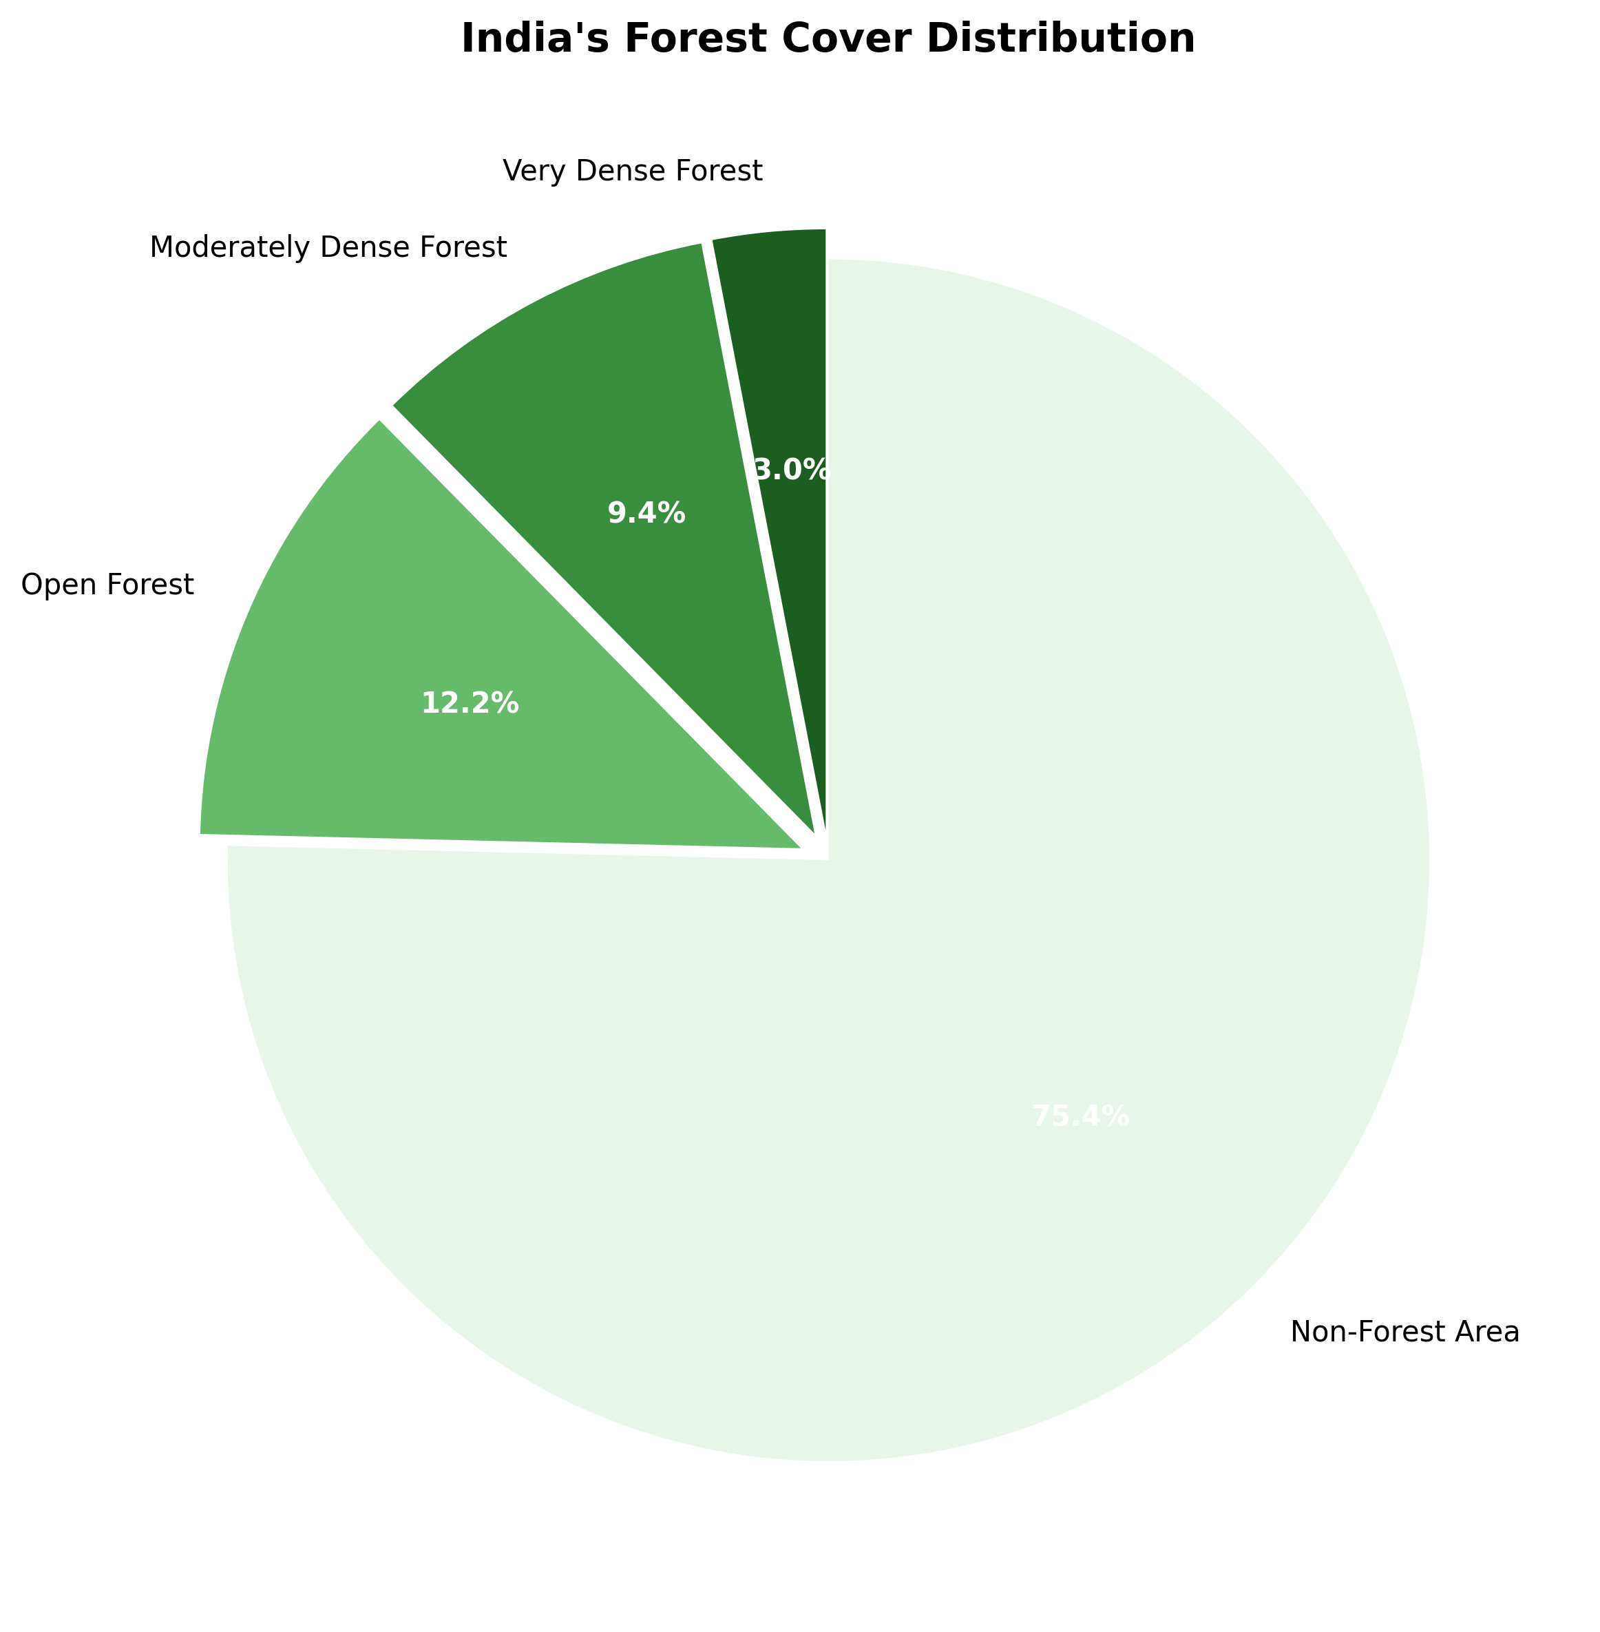

3.3 Coastal Regulation Zone Notification
The Coastal Regulation Zone (CRZ) Notification, issued under the EPA in 1991 and substantially revised in 2011 and 2019, regulates development activities along India's 7,517-kilometer coastline and coastal waters. The notification classifies coastal areas into four categories based on ecological sensitivity, population density, and development status, prescribing specific regulations for each zone. CRZ regulations aim to protect coastal ecosystems, conserve marine biodiversity, ensure livelihood security of coastal communities, and promote sustainable coastal development.

CRZ Categories and Regulations
CRZ-I encompasses ecologically sensitive areas including mangroves, coral reefs, sand dunes, mudflats, national parks, marine parks, and areas between Low Tide Line (LTL) and High Tide Line (HTL). Development is severely restricted, permitting only activities essential for conservation, public utilities, and traditional fishing. CRZ-II covers developed areas within municipal limits having substantial built-up infrastructure, where reconstruction and new construction are permitted subject to floor space index and setback regulations.
CRZ-III includes relatively undeveloped coastal areas in rural regions, subdivided into densely populated and sparsely populated areas with differential development norms. CRZ-IV covers aquatic areas including territorial waters and exclusive economic zones, regulating activities like port development, offshore drilling, and marine mining. The 2019 notification introduced several modifications including differential treatment for island territories, streamlined clearance procedures, and enhanced provisions for eco-tourism and renewable energy projects.

Chapter 4: Environmental Impact Assessment

4.1 EIA Notification, 2006
The Environmental Impact Assessment (EIA) Notification, 2006 mandates prior environmental clearance for specified development projects based on their environmental significance. This notification, issued under Section 3 of the EPA, replaced the 1994 EIA notification, expanding coverage and streamlining procedures. EIA serves as a preventive tool, requiring project proponents to assess potential environmental impacts and propose mitigation measures before project implementation.
The notification categorizes projects into Category A and Category B based on spatial extent, potential impacts, and investment. Category A projects undergo appraisal by the Expert Appraisal Committee at the central level, while Category B projects receive state-level clearance. Category B projects are further subdivided into B1 (requiring EIA) and B2 (exempt from EIA but requiring application scrutiny). The categorization enables risk-based regulation, focusing detailed assessment on projects with significant environmental implications.

EIA Process and Stages
The EIA process comprises four stages: Screening determines whether a project requires EIA; Scoping identifies significant issues and Terms of Reference for impact assessment; EIA study evaluates baseline conditions, predicts impacts, and designs mitigation measures; and Public consultation enables affected communities to provide inputs. The final EIA report is submitted to the Expert Appraisal Committee, which evaluates technical aspects, considers public concerns, and recommends grant or denial of environmental clearance.
Environmental clearance validity ranges from seven to thirty years depending on project type, subject to compliance with conditions and periodic monitoring. Projects must commence construction within specified timelines to maintain clearance validity. The notification prescribes post-clearance compliance monitoring through half-yearly reports, surprise inspections, and remote sensing-based surveillance. Non-compliance attracts suspension or revocation of clearance, prosecution under EPA, and civil liability for environmental damages.

Environmental Clearance Process Flow
The following table outlines the systematic process for obtaining environmental clearance in India:
Stage | Activities | Timeline
1. Screening | Determination of EIA requirement, project categorization | Immediate (upon application)
2. Scoping | Terms of Reference preparation, identification of key impacts | 60 days from receipt of application
3. EIA Study | Baseline data collection, impact prediction, mitigation planning | 6-12 months (seasonal variations)
4. Public Hearing | Public notification, stakeholder consultation, grievance recording | 30 days from EIA report submission
5. Appraisal | Expert committee evaluation, site visit, technical review | 60 days from final EIA report
6. Decision | Grant/rejection of clearance with conditions | 45 days from appraisal completion
7. Monitoring | Compliance verification, periodic reporting, inspections | Continuous throughout project lifecycle

Chapter 5: Waste Management Framework

5.1 Solid Waste Management Rules, 2016
The Solid Waste Management Rules, 2016 replaced the Municipal Solid Wastes (Management and Handling) Rules, 2000, establishing a comprehensive regulatory framework for urban and rural waste management. These rules reflect India's commitment to circular economy principles, emphasizing waste reduction, segregation at source, scientific processing, and resource recovery. The rules extend producer responsibility to manufacturers, introducing Extended Producer Responsibility (EPR) for packaging waste.
The rules mandate waste segregation into wet (biodegradable), dry (recyclable), and hazardous categories at the point of generation. Urban local bodies must establish comprehensive waste management systems including collection, transportation, processing, and disposal infrastructure. The rules prescribe specific timelines for compliance, with metropolitan cities required to achieve 100% source segregation within two years. Penalties for non-compliance include fines and imprisonment under environmental protection laws.

Extended Producer Responsibility
EPR provisions require brand owners and producers to collect and channelize packaging waste for recycling or proper disposal. Producers must establish collection mechanisms through agreements with local bodies or waste management agencies. The rules set collection targets starting at 50% in the first year and progressively increasing to 75% by the fourth year. Non-compliance attracts environmental compensation based on waste quantity and market value of packaging materials. EPR has incentivized development of recycling infrastructure and formalization of the informal waste sector.

5.2 Plastic Waste Management Rules
The Plastic Waste Management Rules, 2016 (amended in 2018 and 2021) address the specific challenge of plastic pollution. The rules prohibit manufacture, sale, and use of plastic carry bags below specified thickness and multi-layered plastics lacking recyclability. The 2021 amendment banned single-use plastic items identified as low utility and high littering potential, including plastic sticks for balloons, flags, candy, ice cream, and polystyrene foam for decoration.
Producers, importers, and brand owners must implement EPR for plastic packaging, with annual collection targets ranging from 25% to 70% depending on category. The rules promote use of recycled plastic content, mandating minimum recycled content in plastic products. State governments must establish systems for plastic waste segregation, collection, and processing. The rules encourage alternative materials and innovative technologies for plastic waste management, including chemical recycling and waste-to-energy conversion.

5.3 E-Waste Management Rules, 2016
E-waste Management Rules, 2016 establish a framework for managing electronic and electrical equipment waste, addressing one of the fastest-growing waste streams globally. The rules apply to manufacturers, producers, refurbishers, dismantlers, and recyclers of electrical and electronic equipment. EPR authorization requires producers to collect and channelize e-waste for environmentally sound recycling, with targets increasing from 30% to 70% over seven years.
The rules mandate deposit refund schemes, take-back systems, and buy-back mechanisms to facilitate e-waste collection. Bulk consumers including government departments and companies must auction or dispose of e-waste through authorized dismantlers and recyclers. The rules prohibit open burning, acid leaching, and informal processing of e-waste. Dismantlers and recyclers require authorization from State Pollution Control Boards, with strict conditions for storage, processing, and disposal to prevent environmental contamination from hazardous constituents including heavy metals and persistent organic pollutants.

Chapter 6: Climate Change and Renewable Energy

6.1 National Action Plan on Climate Change
India's National Action Plan on Climate Change (NAPCC), launched in 2008, represents the country's comprehensive strategy for climate change mitigation and adaptation. The plan comprises eight national missions addressing solar energy, enhanced energy efficiency, sustainable habitat, water conservation, Himalayan ecosystem preservation, green India, sustainable agriculture, and strategic knowledge. These missions translate India's climate commitments into actionable programs with measurable outcomes.
The National Solar Mission aims to establish India as a global solar energy leader, targeting 100 GW grid-connected solar power capacity by 2022. The Enhanced Energy Efficiency Mission promotes energy efficiency across industries through market-based mechanisms including Perform, Achieve and Trade (PAT) schemes. The National Mission on Sustainable Habitat focuses on sustainable urban planning, energy-efficient buildings, and urban waste management. Each mission operates through dedicated institutional mechanisms with central and state-level implementation agencies.

State Action Plans
All states have prepared State Action Plans on Climate Change (SAPCC) aligning with national missions while addressing region-specific vulnerabilities. SAPCCs identify sectoral adaptation and mitigation strategies, establish implementation timelines, and mobilize resources. Priority sectors typically include agriculture, water resources, forestry, coastal zone management, and disaster preparedness. State governments establish dedicated climate change cells for coordination, monitoring, and reporting. Regular reviews assess progress, identify gaps, and recommend course corrections.

6.2 Legal Framework for Renewable Energy
India's renewable energy framework encompasses constitutional provisions, statutory regulations, and policy instruments promoting clean energy development. The Electricity Act, 2003 provides the foundational legal framework, mandating renewable purchase obligations and enabling third-party sale of renewable electricity. The act empowers regulatory commissions to fix feed-in tariffs, ensuring reasonable returns for renewable energy projects while protecting consumer interests.
The National Electricity Policy and Tariff Policy incorporate renewable energy objectives, mandating minimum renewable purchase obligations for distribution licensees. The Central Electricity Regulatory Commission has issued regulations for renewable energy certificates, connectivity standards, and forecasting and scheduling. State regulatory commissions determine state-specific policies, tariffs, and support mechanisms. The Energy Conservation Act, 2001 establishes the Bureau of Energy Efficiency, promoting energy conservation and efficiency across sectors.

Renewable Energy Policies
India has implemented various schemes promoting renewable energy deployment including the Jawaharlal Nehru National Solar Mission, Wind Power Programme, and Biomass Power and Cogeneration Programme. The Production Linked Incentive scheme for solar PV modules aims to create domestic manufacturing capacity. Viability Gap Funding supports financially unviable but economically justified renewable energy projects. The government has established dedicated renewable energy agencies including Solar Energy Corporation of India and NTPC Renewable Energy Limited for project development and implementation.

India's Renewable Energy Capacity Growth
India has achieved remarkable growth in renewable energy capacity:
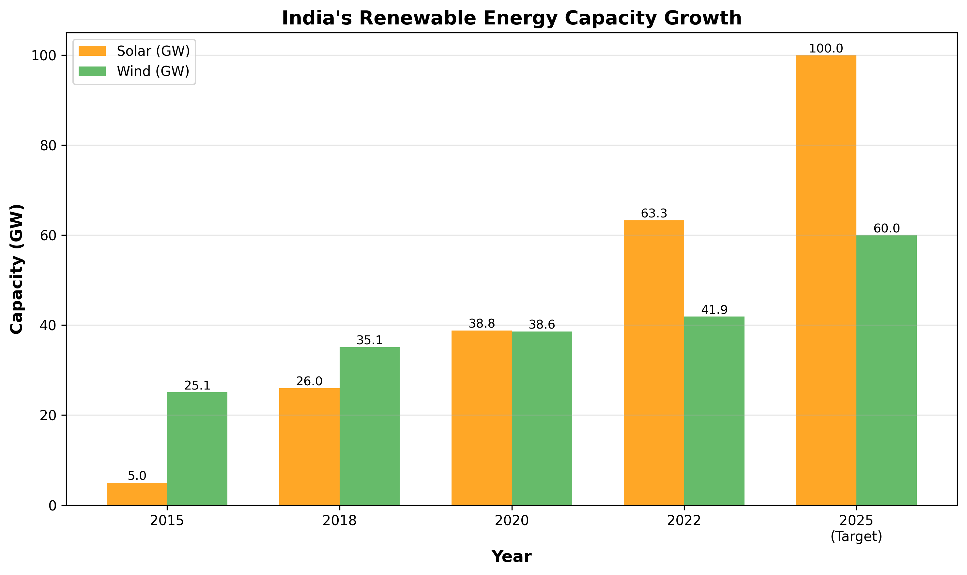

Chapter 7: Judicial Interpretation and Public Interest Litigation

7.1 Role of Indian Judiciary
The Indian judiciary has played a transformative role in developing environmental jurisprudence through progressive interpretation of constitutional provisions and statutory laws. The Supreme Court and High Courts have expanded the scope of environmental rights, established liability principles, and directed government action on environmental matters. Judicial activism has compensated for legislative gaps and enforcement deficiencies, making courts primary forums for environmental protection.
The doctrine of public interest litigation revolutionized access to environmental justice by relaxing locus standi requirements. Any concerned citizen or organization can approach courts on behalf of affected communities or environmental resources. This procedural innovation enabled widespread environmental activism, with courts entertaining petitions addressing air and water pollution, forest conservation, wildlife protection, and industrial hazards.

Landmark Judicial Pronouncements
In M.C. Mehta v. Union of India (Oleum Gas Leak Case, 1987), the Supreme Court established the doctrine of absolute liability for hazardous industries, rejecting the defense of 'act of God' or 'stranger's act.' The judgment mandated stringent safety standards and compensation for victims without requiring proof of negligence. This principle has been consistently applied to cases involving industrial accidents, toxic releases, and environmental catastrophes.
The Vellore Citizens Welfare Forum case (1996) explicitly recognized sustainable development, precautionary principle, and polluter pays principle as integral to Indian environmental law. The Court held these principles form part of the law of the land and must guide environmental decision-making. This judgment influenced subsequent legislation and policy formulation, embedding international environmental principles in domestic jurisprudence.
In T.N. Godavarman Thirumulpad v. Union of India (1997-present), an ongoing case spanning over two decades, the Supreme Court issued over 100 orders addressing forest conservation, wildlife protection, and illegal mining. The Court established the Central Empowered Committee to monitor forest-related matters, created institutional mechanisms for enforcement, and issued comprehensive directions on forest working plans, protected areas, and compensatory afforestation.

7.2 National Green Tribunal
The National Green Tribunal Act, 2010 established a specialized environmental court for expeditious disposal of environmental cases and compensation claims. The NGT represents institutional innovation addressing judicial backlog and technical complexity of environmental disputes. The tribunal comprises judicial and expert members, enabling informed decision-making on scientific and technical issues. The Act consolidates jurisdiction over environmental matters previously scattered across various courts and tribunals.
The NGT exercises original jurisdiction over substantial questions relating to environment, civil cases involving damages from environmental harm, and violations of environmental laws including the Water Act, Air Act, EPA, and Forest Act. The tribunal also has appellate jurisdiction over orders of regulatory authorities including SPCBs, expert appraisal committees, and National Biodiversity Authority. The Act mandates disposal of applications within six months, ensuring swift justice.

NGT's Contributions
The NGT has issued landmark orders on diverse environmental issues including groundwater depletion, plastic pollution, industrial effluents, noise pollution, and construction waste. The tribunal has imposed substantial environmental compensation, directed closure of non-compliant industries, and mandated implementation of environmental safeguards. The NGT's orders have catalyzed policy reforms, improved regulatory enforcement, and enhanced environmental accountability. Regional benches in Bhopal, Pune, Kolkata, and Chennai ensure accessibility across the country.

Chapter 8: Emerging Environmental Challenges

8.1 Air Quality Management
Air pollution represents India's most pressing environmental health challenge, with multiple cities ranking among the world's most polluted. The Commission for Air Quality Management in National Capital Region and Adjoining Areas Act, 2021 established a statutory authority with powers to coordinate regional air quality management, impose penalties, and direct enforcement actions. The Commission supersedes previous authorities including the Environment Pollution (Prevention and Control) Authority, consolidating regulatory functions.
The Act grants the Commission wide-ranging powers including restricting industries, regulating construction activities, controlling vehicular emissions, and prohibiting polluting fuels. Sub-committees address specific sources including industrial emissions, vehicular pollution, dust management, and stubble burning. The Commission coordinates with state governments, pollution control boards, and municipal authorities to implement comprehensive air quality action plans. Penalties include imprisonment up to five years and substantial fines.

National Clean Air Programme
The National Clean Air Programme (NCAP), launched in 2019, aims to reduce particulate matter concentrations by 20-30% by 2024 compared to 2017 levels. The program adopts a collaborative approach involving central ministries, state governments, and local bodies. City-specific action plans address major pollution sources including vehicular emissions, industrial pollution, construction dust, waste burning, and domestic biomass combustion. NCAP promotes clean technologies, renewable energy, public transportation, and awareness campaigns. The program establishes a national monitoring network, research initiatives, and institutional capacity building.

8.2 Water Resource Management
India faces severe water stress with declining groundwater levels, contaminated surface water, and interstate water disputes. The National Water Policy, 2012 emphasizes integrated water resources management, community participation, and equitable distribution. The policy recognizes access to safe drinking water as a fundamental right, prioritizing domestic water supply over irrigation and industrial uses. Water conservation, efficiency improvement, and aquifer recharge constitute core objectives.
The Jal Shakti Abhiyan promotes water conservation through rainwater harvesting, watershed development, and renovation of traditional water bodies. The Atal Bhujal Yojana addresses groundwater depletion in priority areas through community-led conservation measures. The government has launched the Jal Jeevan Mission to provide functional household tap connections to all rural households by 2024. These initiatives combine infrastructure development with behavioral change and community participation.

Interstate Water Disputes
The Interstate River Water Disputes Act, 1956 provides mechanisms for resolving water-sharing conflicts between states. Water tribunals adjudicate disputes through detailed investigations, hearings, and technical assessments. Major tribunals include Cauvery Water Disputes Tribunal, Krishna Water Disputes Tribunal, and Godavari Water Disputes Tribunal. The 2019 amendment established a single permanent tribunal with multiple benches to expedite dispute resolution. However, implementation of tribunal awards remains contentious, requiring political will and interstate cooperation.

Environmental Compliance and Enforcement Mechanisms
India employs diverse mechanisms to ensure environmental compliance:
Mechanism | Description | Authority
Consent Orders | Prior authorization for operations with conditions | State PCBs
Inspections | Site visits, sample collection, compliance verification | PCBs, Forest Dept
Directions | Compliance orders for remedial action | MoEFCC, PCBs
Closure Orders | Shutdown for serious violations | State PCBs, NGT
Prosecution | Criminal proceedings for violations | Courts, NGT
Compensation | Financial liability for environmental damage | NGT, Courts
Public Interest Litigation | Citizen-initiated legal action | Supreme Court, HCs, NGT

Chapter 9: International Environmental Obligations

9.1 Climate Change Commitments
India is party to the United Nations Framework Convention on Climate Change, Kyoto Protocol, and Paris Agreement, undertaking both mitigation and adaptation commitments. India's Nationally Determined Contributions (NDC) under the Paris Agreement include reducing emissions intensity of GDP by 33-35% below 2005 levels by 2030, achieving 40% cumulative electric power installed capacity from non-fossil fuel sources, and creating additional carbon sink of 2.5-3 billion tonnes of CO2 equivalent through forest and tree cover.
At COP26 in Glasgow, India announced enhanced commitments including reaching 500 GW non-fossil energy capacity by 2030, meeting 50% energy requirements from renewable sources, reducing total projected carbon emissions by one billion tonnes, and achieving net-zero emissions by 2070. These ambitious targets require transformative changes across energy, transport, industry, and agriculture sectors. India has consistently emphasized climate justice, common but differentiated responsibilities, and the need for developed countries to provide climate finance and technology transfer.

9.2 Biodiversity Conservation Treaties
India is a mega-diverse country and party to the Convention on Biological Diversity (CBD), implementing obligations through the Biological Diversity Act, 2002. The Act establishes a three-tier institutional structure comprising the National Biodiversity Authority, State Biodiversity Boards, and Biodiversity Management Committees at local levels. The Act regulates access to biological resources, ensures equitable benefit sharing, and protects traditional knowledge.
India is party to the Convention on International Trade in Endangered Species of Wild Fauna and Flora (CITES), controlling trade in endangered wildlife and plants. The Wildlife Protection Act schedules correspond to CITES appendices, ensuring domestic legal backing for international commitments. India actively participates in CITES meetings, proposes species listings, and implements trade restrictions. The government has established specialized enforcement agencies including the Wildlife Crime Control Bureau to combat illegal wildlife trade.

Wetlands and Migratory Species
The Ramsar Convention on Wetlands protects internationally important wetlands. India has designated 75 Ramsar sites covering over 1.3 million hectares, including Chilika Lake, Keoladeo National Park, and Sundarbans. The Wetlands (Conservation and Management) Rules, 2017 prohibit activities detrimental to wetland ecology including conversion, pollution discharge, and unauthorized construction. India is also party to the Convention on Migratory Species, protecting migratory birds and aquatic species through habitat conservation and reducing anthropogenic threats.

Chapter 10: Institutional Framework and Governance

10.1 Ministry of Environment, Forest and Climate Change
The Ministry of Environment, Forest and Climate Change (MoEFCC) serves as the nodal agency for environmental planning, policy formulation, and coordination. The ministry administers environmental laws, issues environmental clearances for major projects, coordinates with state governments and international agencies, and monitors implementation of environmental programs. The ministry's organizational structure includes divisions for climate change, forests, wildlife, environmental appraisal, pollution control, and international cooperation.
The ministry operates through various subordinate and attached offices including the Central Pollution Control Board, National Biodiversity Authority, Central Zoo Authority, and Botanical Survey of India. Expert committees and technical bodies assist in policy formulation and project appraisal. The ministry coordinates national missions under the National Action Plan on Climate Change, manages international environmental conventions, and mobilizes climate finance. Regular monitoring, evaluation, and reporting mechanisms ensure accountability and transparency.

10.2 State Environmental Institutions
State governments establish environmental departments managing state-level environmental policies and programs. State Environment Impact Assessment Authorities grant environmental clearances for Category B projects. State Pollution Control Boards constitute the operational tier for pollution control, conducting inspections, monitoring compliance, and enforcing regulations. State Biodiversity Boards implement provisions of the Biological Diversity Act, documenting biodiversity resources and regulating access.
Biodiversity Management Committees at local levels involve communities in biodiversity conservation, documenting traditional knowledge and regulating access to biological resources. This three-tier institutional framework ensures participatory governance, combining regulatory enforcement with community involvement. State governments prepare State of Environment Reports, conduct environmental awareness campaigns, and implement environmental education programs. Coordination between central and state institutions remains crucial for effective environmental governance.

Conclusion
India's environmental legal framework represents a sophisticated and evolving system designed to balance development imperatives with ecological sustainability. The constitutional foundation, comprehensive statutory architecture, robust regulatory mechanisms, and dynamic judicial interpretation collectively establish one of the developing world's most advanced environmental governance systems. From foundational legislation enacted in the 1970s to contemporary regulations addressing emerging challenges, Indian environmental law has progressively expanded in scope, stringency, and effectiveness.
The journey from reactive pollution control to proactive environmental management reflects growing environmental consciousness and commitment to sustainable development. Constitutional provisions establishing state and citizen obligations, umbrella legislation like the Environment Protection Act providing comprehensive regulatory powers, sectoral laws addressing specific environmental media, and specialized institutions including the National Green Tribunal demonstrate the multifaceted approach to environmental protection.
Judicial activism has been instrumental in filling legislative gaps, enforcing regulatory compliance, and expanding environmental rights. The Supreme Court and High Courts have established principles of absolute liability, sustainable development, precautionary approach, and polluter pays, which guide environmental decision-making. Public interest litigation has democratized environmental justice, enabling citizens to challenge environmentally harmful actions and demand government accountability.
However, significant challenges persist. Implementation gaps, enforcement deficiencies, institutional capacity constraints, and conflicts between development and conservation objectives continue to undermine environmental protection. Air and water pollution remain severe public health threats, forest degradation and biodiversity loss continue, and climate change impacts intensify. Addressing these challenges requires strengthened institutions, enhanced enforcement, increased resources, technological innovation, and behavioral change.
The path forward requires integrating environmental considerations into all development planning and decision-making. Economic growth must be decoupled from environmental degradation through resource efficiency, circular economy principles, and clean technologies. Renewable energy expansion, sustainable urban development, climate-resilient agriculture, and ecosystem restoration must be accelerated. International cooperation, climate finance, and technology transfer remain essential for achieving ambitious climate and biodiversity targets.
Civil society engagement, corporate responsibility, and community participation are vital for environmental sustainability. Environmental education, awareness campaigns, and behavioral change initiatives can foster environmental consciousness. Business must embrace environmental, social, and governance principles, moving beyond regulatory compliance to proactive sustainability leadership. Local communities, particularly indigenous peoples, must be recognized as environmental stewards with rights and responsibilities.
India's environmental journey reflects broader global transitions toward sustainable development. As the world's most populous democracy and third-largest economy, India's environmental performance has global implications. The legal framework established over five decades provides a strong foundation for addressing contemporary and future environmental challenges. Success requires political will, adequate resources, institutional effectiveness, technological innovation, and societal commitment to environmental values. The goal is not merely environmental protection but achieving harmony between human development and ecological integrity, ensuring a sustainable and equitable future for current and coming generations.

References and Further Reading

Statutes and Regulations:
- The Constitution of India, 1950
- Wildlife (Protection) Act, 1972
- Water (Prevention and Control of Pollution) Act, 1974
- Forest (Conservation) Act, 1980
- Air (Prevention and Control of Pollution) Act, 1981
- Environment (Protection) Act, 1986
- Biological Diversity Act, 2002
- National Green Tribunal Act, 2010
- EIA Notification, 2006 and amendments
- Coastal Regulation Zone Notification, 2019
- Solid Waste Management Rules, 2016
- Plastic Waste Management Rules, 2016 (amended 2021)
- E-Waste Management Rules, 2016

Government Resources:
- Ministry of Environment, Forest and Climate Change - moef.gov.in
- Central Pollution Control Board - cpcb.nic.in
- National Green Tribunal - greentribunal.gov.in
- Forest Survey of India - fsi.nic.in
- National Biodiversity Authority - nbaindia.org

Key Judicial Pronouncements:
- Rural Litigation and Entitlement Kendra v. State of UP (1985)
- M.C. Mehta v. Union of India (Oleum Gas Leak Case, 1987)
- Vellore Citizens Welfare Forum v. Union of India (1996)
- T.N. Godavarman Thirumulpad v. Union of India (1997-ongoing)
- Indian Council for Enviro-Legal Action v. Union of India (1996)

International Conventions and Treaties:
- United Nations Framework Convention on Climate Change (UNFCCC)
- Paris Agreement on Climate Change
- Convention on Biological Diversity (CBD)
- Convention on International Trade in Endangered Species (CITES)
- Ramsar Convention on Wetlands
- Convention on Migratory Species

About This Publication
This comprehensive ebook provides an in-depth analysis of environmental laws governing sustainability in India. The content covers constitutional provisions, statutory frameworks, regulatory mechanisms, judicial interpretations, and institutional structures that collectively establish India's environmental governance system.
The publication is intended for legal professionals, policy makers, environmental consultants, students, researchers, and concerned citizens seeking to understand India's environmental legal framework. The analysis integrates legal, technical, and policy perspectives, examining both achievements and challenges in environmental protection.
While every effort has been made to ensure accuracy, environmental law is dynamic and subject to frequent amendments, notifications, and judicial interpretations. Readers should consult official government sources, legal databases, and professional advisors for current information and specific legal guidance.
Edition: 2026
Copyright © 2026. All rights reserved.

