CLIMATE FINANCE
AND THE FINANCIAL SECTOR
Actors, Actions, and Pathways to a Low-Carbon,
Climate-Resilient Economy
A Comprehensive Ebook
2026 Edition

Preface
This ebook provides a comprehensive examination of climate finance and the financial sector's critical role in driving the transition to a low-carbon, climate-resilient economy. Drawing from extensive academic research, policy analyses, and practitioner insights, this work synthesizes current knowledge while identifying pathways forward.
The urgency of climate action cannot be overstated. With global temperatures rising and climate impacts intensifying, the financial sector must rapidly scale its response. This ebook illuminates both the progress made and the substantial gaps remaining, offering evidence-based insights for policymakers, financial professionals, researchers, and engaged citizens.

Executive Summary
The transformation toward a low-carbon, climate-resilient economy represents one of the defining challenges of the twenty-first century, requiring unprecedented mobilization of financial resources and fundamental restructuring of global financial systems. This ebook examines the critical role of climate finance and financial sector actors in driving climate mitigation and adaptation, analyzing the complex ecosystem of public and private institutions, mechanisms, and instruments that channel capital toward climate solutions.
The analysis encompasses multilateral development banks, bilateral climate funds, commercial banks, institutional investors, insurance companies, central banks, and regulatory authorities, examining how each actor contributes to or impedes climate finance mobilization. Particular emphasis is placed on the transition from billions to trillions in annual climate investment needs, the role of blended finance in de-risking private investment, innovative financial instruments, and emerging frameworks of climate risk disclosure.

Chapter 1: The Climate Finance Imperative
Climate change represents an existential threat to human civilization and natural ecosystems, driven fundamentally by greenhouse gas emissions from fossil fuel combustion and land use change. The Intergovernmental Panel on Climate Change (IPCC) concludes with high confidence that limiting warming to 1.5°C above pre-industrial levels requires immediate, rapid, and sustained reductions in global emissions, reaching net-zero CO2 emissions around mid-century (IPCC, 2023).
Current climate finance flows fall dramatically short of requirements. The Climate Policy Initiative estimates that global climate finance flows reached approximately $1.3 trillion in 2021-2022, a substantial increase from previous years but still far below the estimated $4.3-4.5 trillion annually needed through 2030 to meet Paris Agreement targets (CPI, 2023).
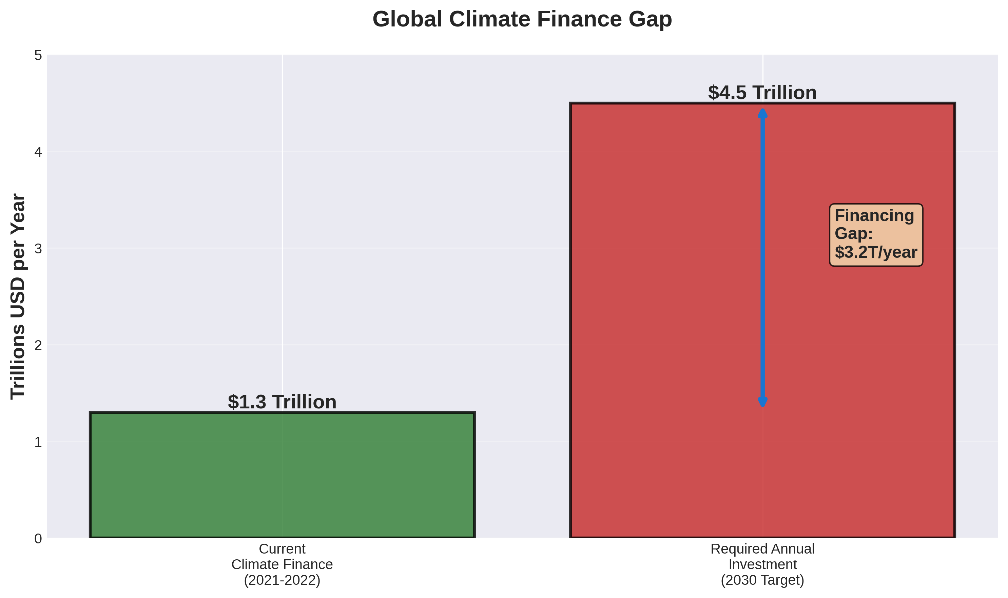
Figure 1.1: Global Climate Finance Gap - Current flows vs. required investment to meet Paris Agreement targets
The financial sector occupies a pivotal position in climate response, functioning simultaneously as a major source of emissions financing, a critical channel for climate investment, and an economy-wide risk transmitter vulnerable to climate-related disruptions. Banks, asset managers, pension funds, insurance companies, and other financial institutions collectively manage over $400 trillion in global financial assets, granting enormous influence over resource allocation (GFANZ, 2021).
However, financial sector transformation faces substantial barriers rooted in institutional structures, regulatory frameworks, market incentives, and political economy. Short-term profit maximization conflicts with long-term climate stability, creating temporal misalignment between financial and planetary timeframes.

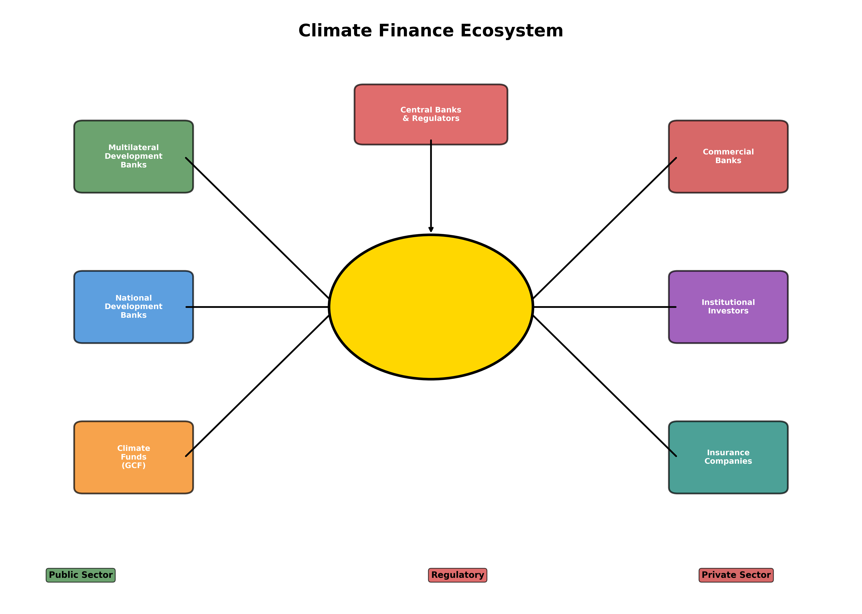
Figure 1.2: Climate Finance Ecosystem - Public and private actors channeling capital toward climate solutions

1.1 Conceptual Foundations of Climate Finance
Climate finance encompasses financial flows directed toward mitigation and adaptation activities that reduce greenhouse gas emissions or enhance resilience to climate impacts. The United Nations Framework Convention on Climate Change (UNFCCC) defines climate finance more specifically as financial resources mobilized to assist developing countries in mitigation and adaptation, reflecting the principle of common but differentiated responsibilities (UNFCCC, 2009).
The distinction between mitigation and adaptation finance reflects different intervention logics and beneficiary structures. Mitigation finance generates global public goods through emissions reductions benefiting all nations. Adaptation finance produces primarily local benefits protecting specific communities and ecosystems from climate impacts.

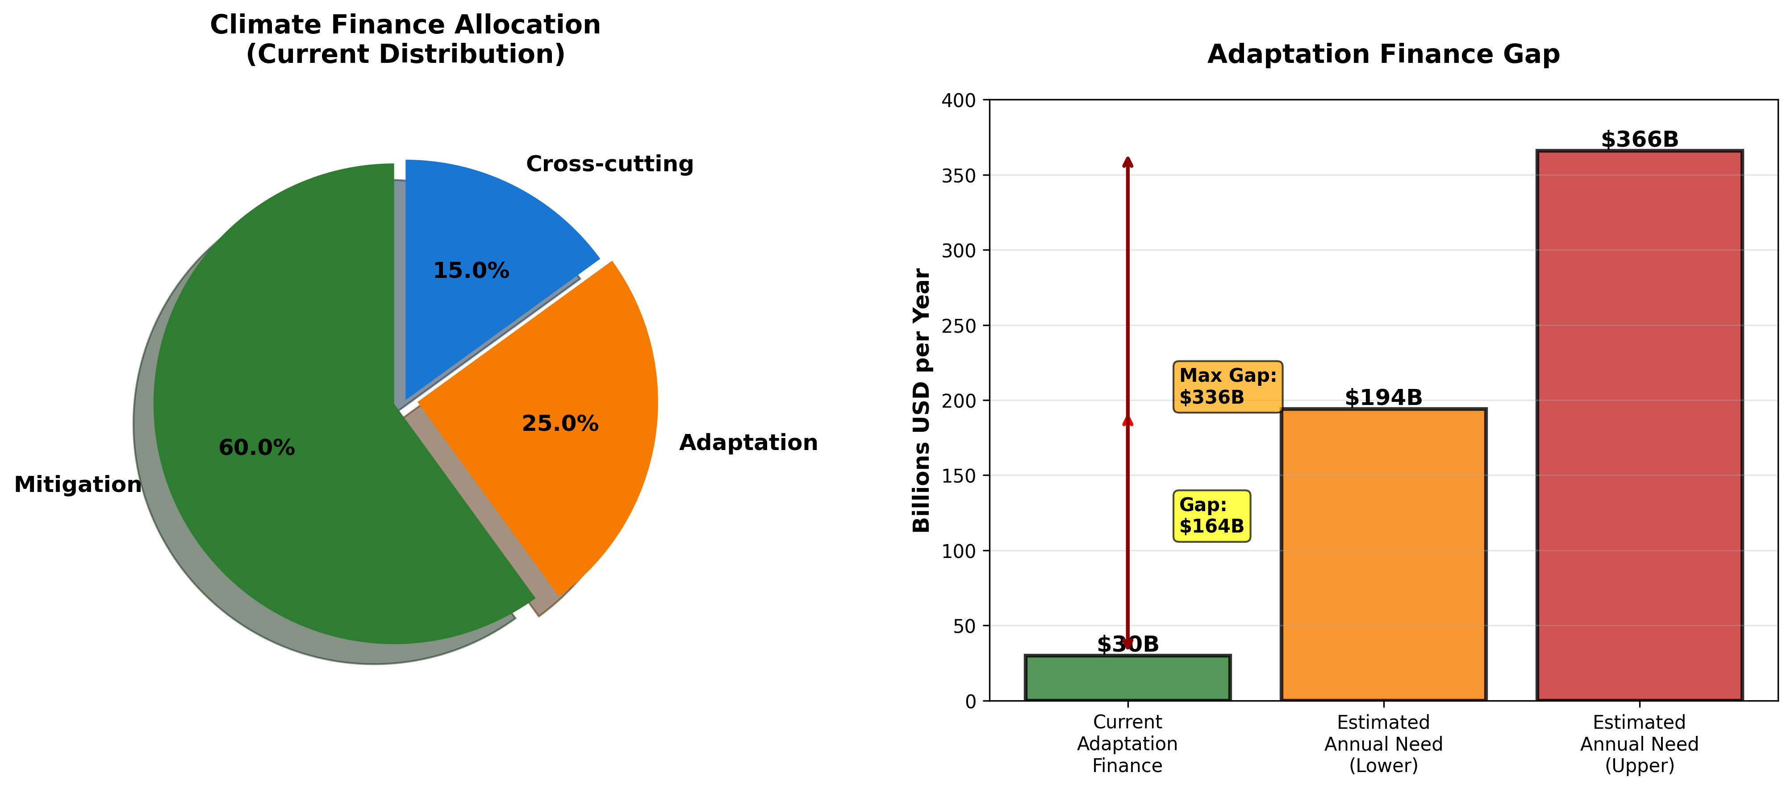
Figure 1.3: Climate Finance Distribution - Current allocation between mitigation and adaptation, highlighting the substantial adaptation financing gap

Chapter 2: Public Climate Finance Institutions

2.1 Multilateral Development Banks
Multilateral development banks (MDBs) constitute the backbone of international public climate finance, collectively providing over $80 billion annually in climate finance through loans, grants, guarantees, and equity investments (MDB, 2023). The World Bank Group, Asian Development Bank, African Development Bank, European Investment Bank, and others have dramatically expanded climate portfolios in recent years.
However, MDB climate finance faces persistent criticisms regarding scale, allocation, and effectiveness. Total MDB climate finance remains a small fraction of overall development finance, with fossil fuel projects still receiving support despite climate commitments. Mitigation dominates adaptation in MDB portfolios despite adaptation's urgency for vulnerable populations.

2.2 Dedicated Climate Funds
Dedicated climate funds created under the UNFCCC channel resources specifically for climate mitigation and adaptation in developing countries. The Green Climate Fund (GCF), established in 2010 and operationalized in 2014, represents the largest dedicated climate fund with over $13 billion pledged by developed countries (GCF, 2024).
The $100 billion annual climate finance commitment made by developed countries in 2009 remains controversial given definitional ambiguities, accounting methodologies, and persistent shortfalls. OECD estimates that developed countries mobilized $89.6 billion in 2021, finally approaching though not meeting the target (OECD, 2023).

Chapter 3: Private Financial Sector Actors

3.1 Commercial Banks and Development Finance
Commercial banks serve as critical intermediaries channeling capital to climate-related projects through corporate lending, project finance, and advisory services. However, actual lending patterns reveal persistent tensions between climate commitments and fossil fuel financing. The Banking on Climate Chaos report documents that the world's 60 largest banks provided $5.5 trillion in fossil fuel financing from 2016-2022 (RAN, 2023).

3.2 Institutional Investors and Asset Managers
Institutional investors including pension funds, insurance companies, and sovereign wealth funds collectively manage over $130 trillion globally. Long investment horizons theoretically position these investors to prioritize sustainability, yet behavioral patterns frequently contradict this logic. Fossil fuel holdings remain substantial in most portfolios despite growing divestment movements.

Chapter 4: Central Banks and Financial Regulators

4.1 Climate Risk and Financial Stability
Central banks and financial regulators increasingly recognize climate change as a source of systemic financial risk requiring integration into prudential supervision. The Network for Greening the Financial System (NGFS), comprising over 120 central banks and supervisors, coordinates research and policy development on climate-related financial risks (NGFS, 2023).
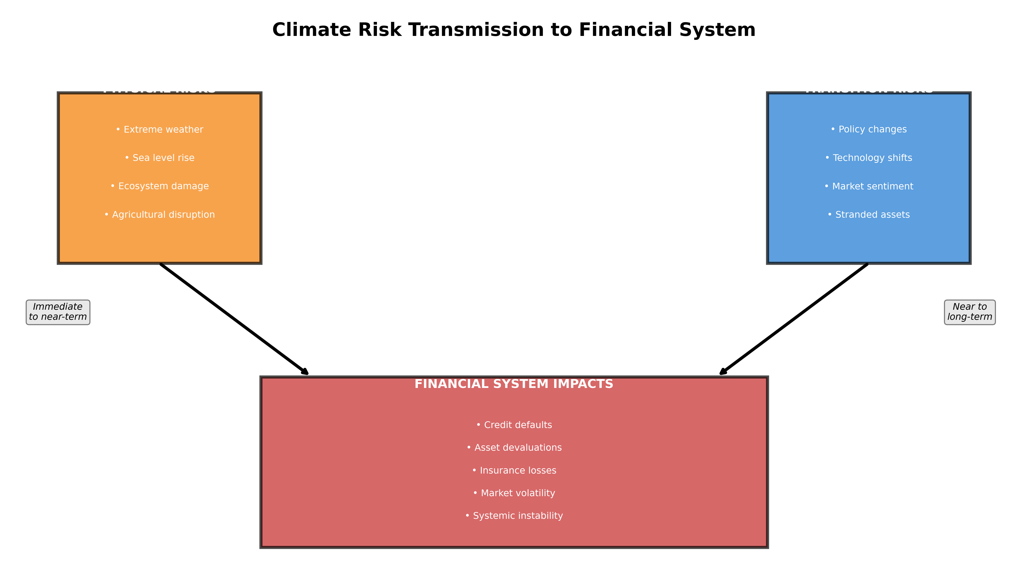
Figure 4.1: Climate Risk Transmission Channels - How physical and transition risks impact the financial system through various pathways
Climate risks manifest through physical risks from climate impacts damaging assets and transition risks from policy changes affecting carbon-intensive industries. Both channels threaten financial stability through loan defaults, asset devaluations, and confidence crises.

Chapter 5: Innovative Financial Instruments

5.1 Green Bonds and Thematic Bonds
Green bonds have emerged as the flagship sustainable finance instrument, with cumulative issuance exceeding $2.5 trillion since inception and annual volumes approaching $500 billion (Climate Bonds Initiative, 2024). These use-of-proceeds bonds finance specific environmental projects including renewable energy, energy efficiency, and clean transportation.
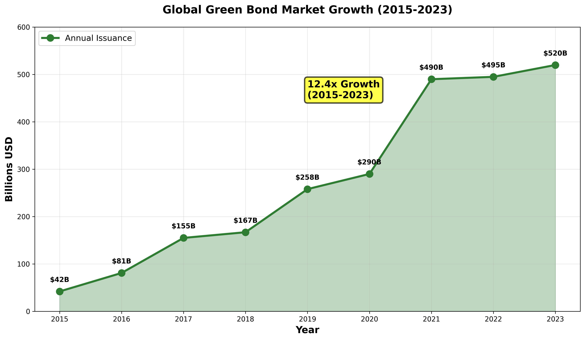
Figure 5.1: Green Bond Market Growth (2015-2023) - Demonstrating rapid expansion from $42 billion to over $500 billion annually

5.2 Blended Finance and De-Risking Mechanisms
Blended finance combines concessional public or philanthropic capital with commercial finance to mobilize private investment in sustainable development projects. Concessional capital absorbs first losses, provides guarantees, or accepts below-market returns, thereby de-risking investments for commercial participants.

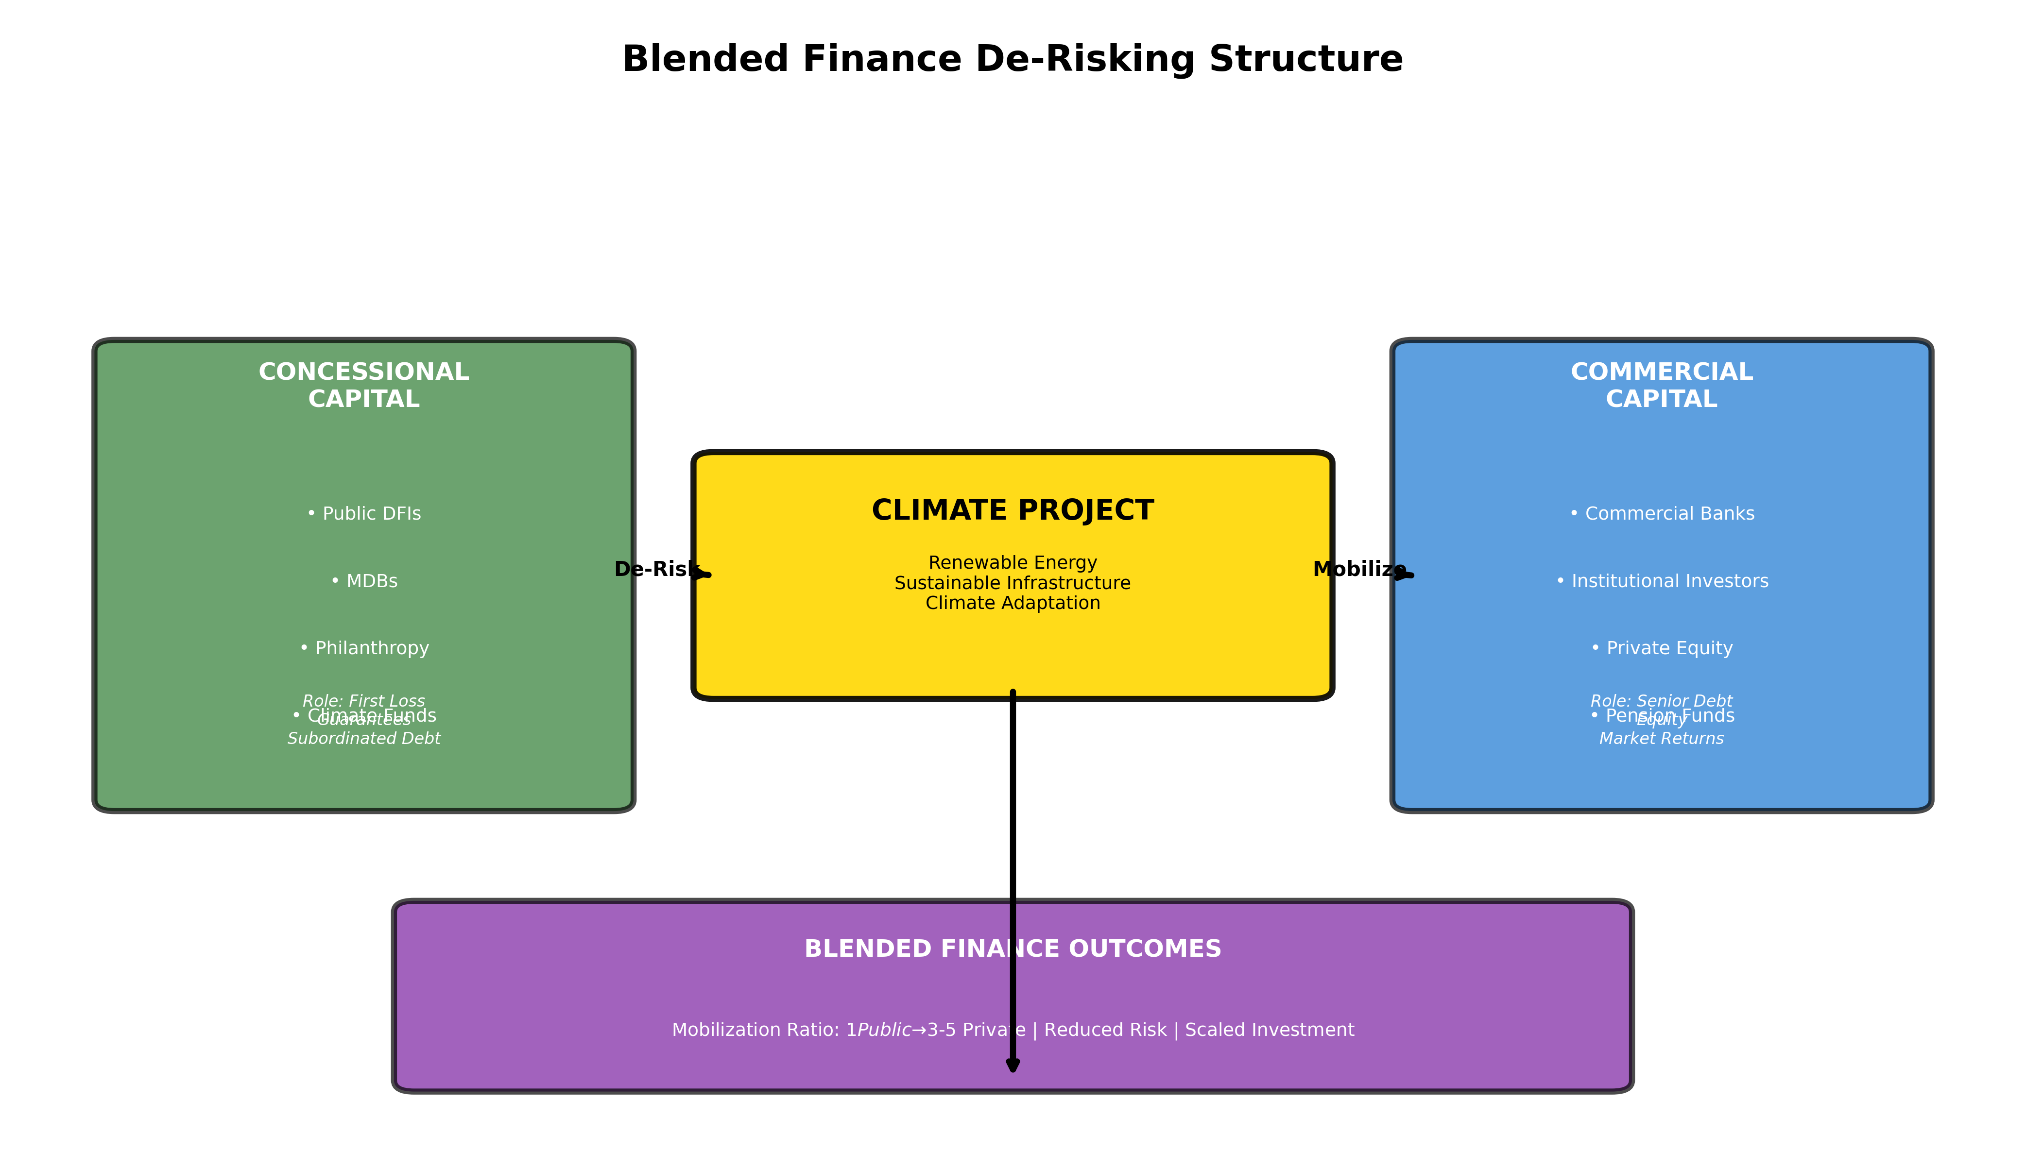
Figure 5.2: Blended Finance De-Risking Structure - How concessional capital mobilizes commercial investment through risk reduction mechanisms

Chapter 6: Climate Risk Disclosure Frameworks

6.1 Task Force on Climate-related Financial Disclosures (TCFD)
The Financial Stability Board's Task Force on Climate-related Financial Disclosures has established the dominant voluntary framework for corporate climate risk disclosure, adopted by thousands of companies worldwide. The TCFD recommendations structure disclosure around four pillars: governance, strategy, risk management, and metrics and targets (TCFD, 2017).
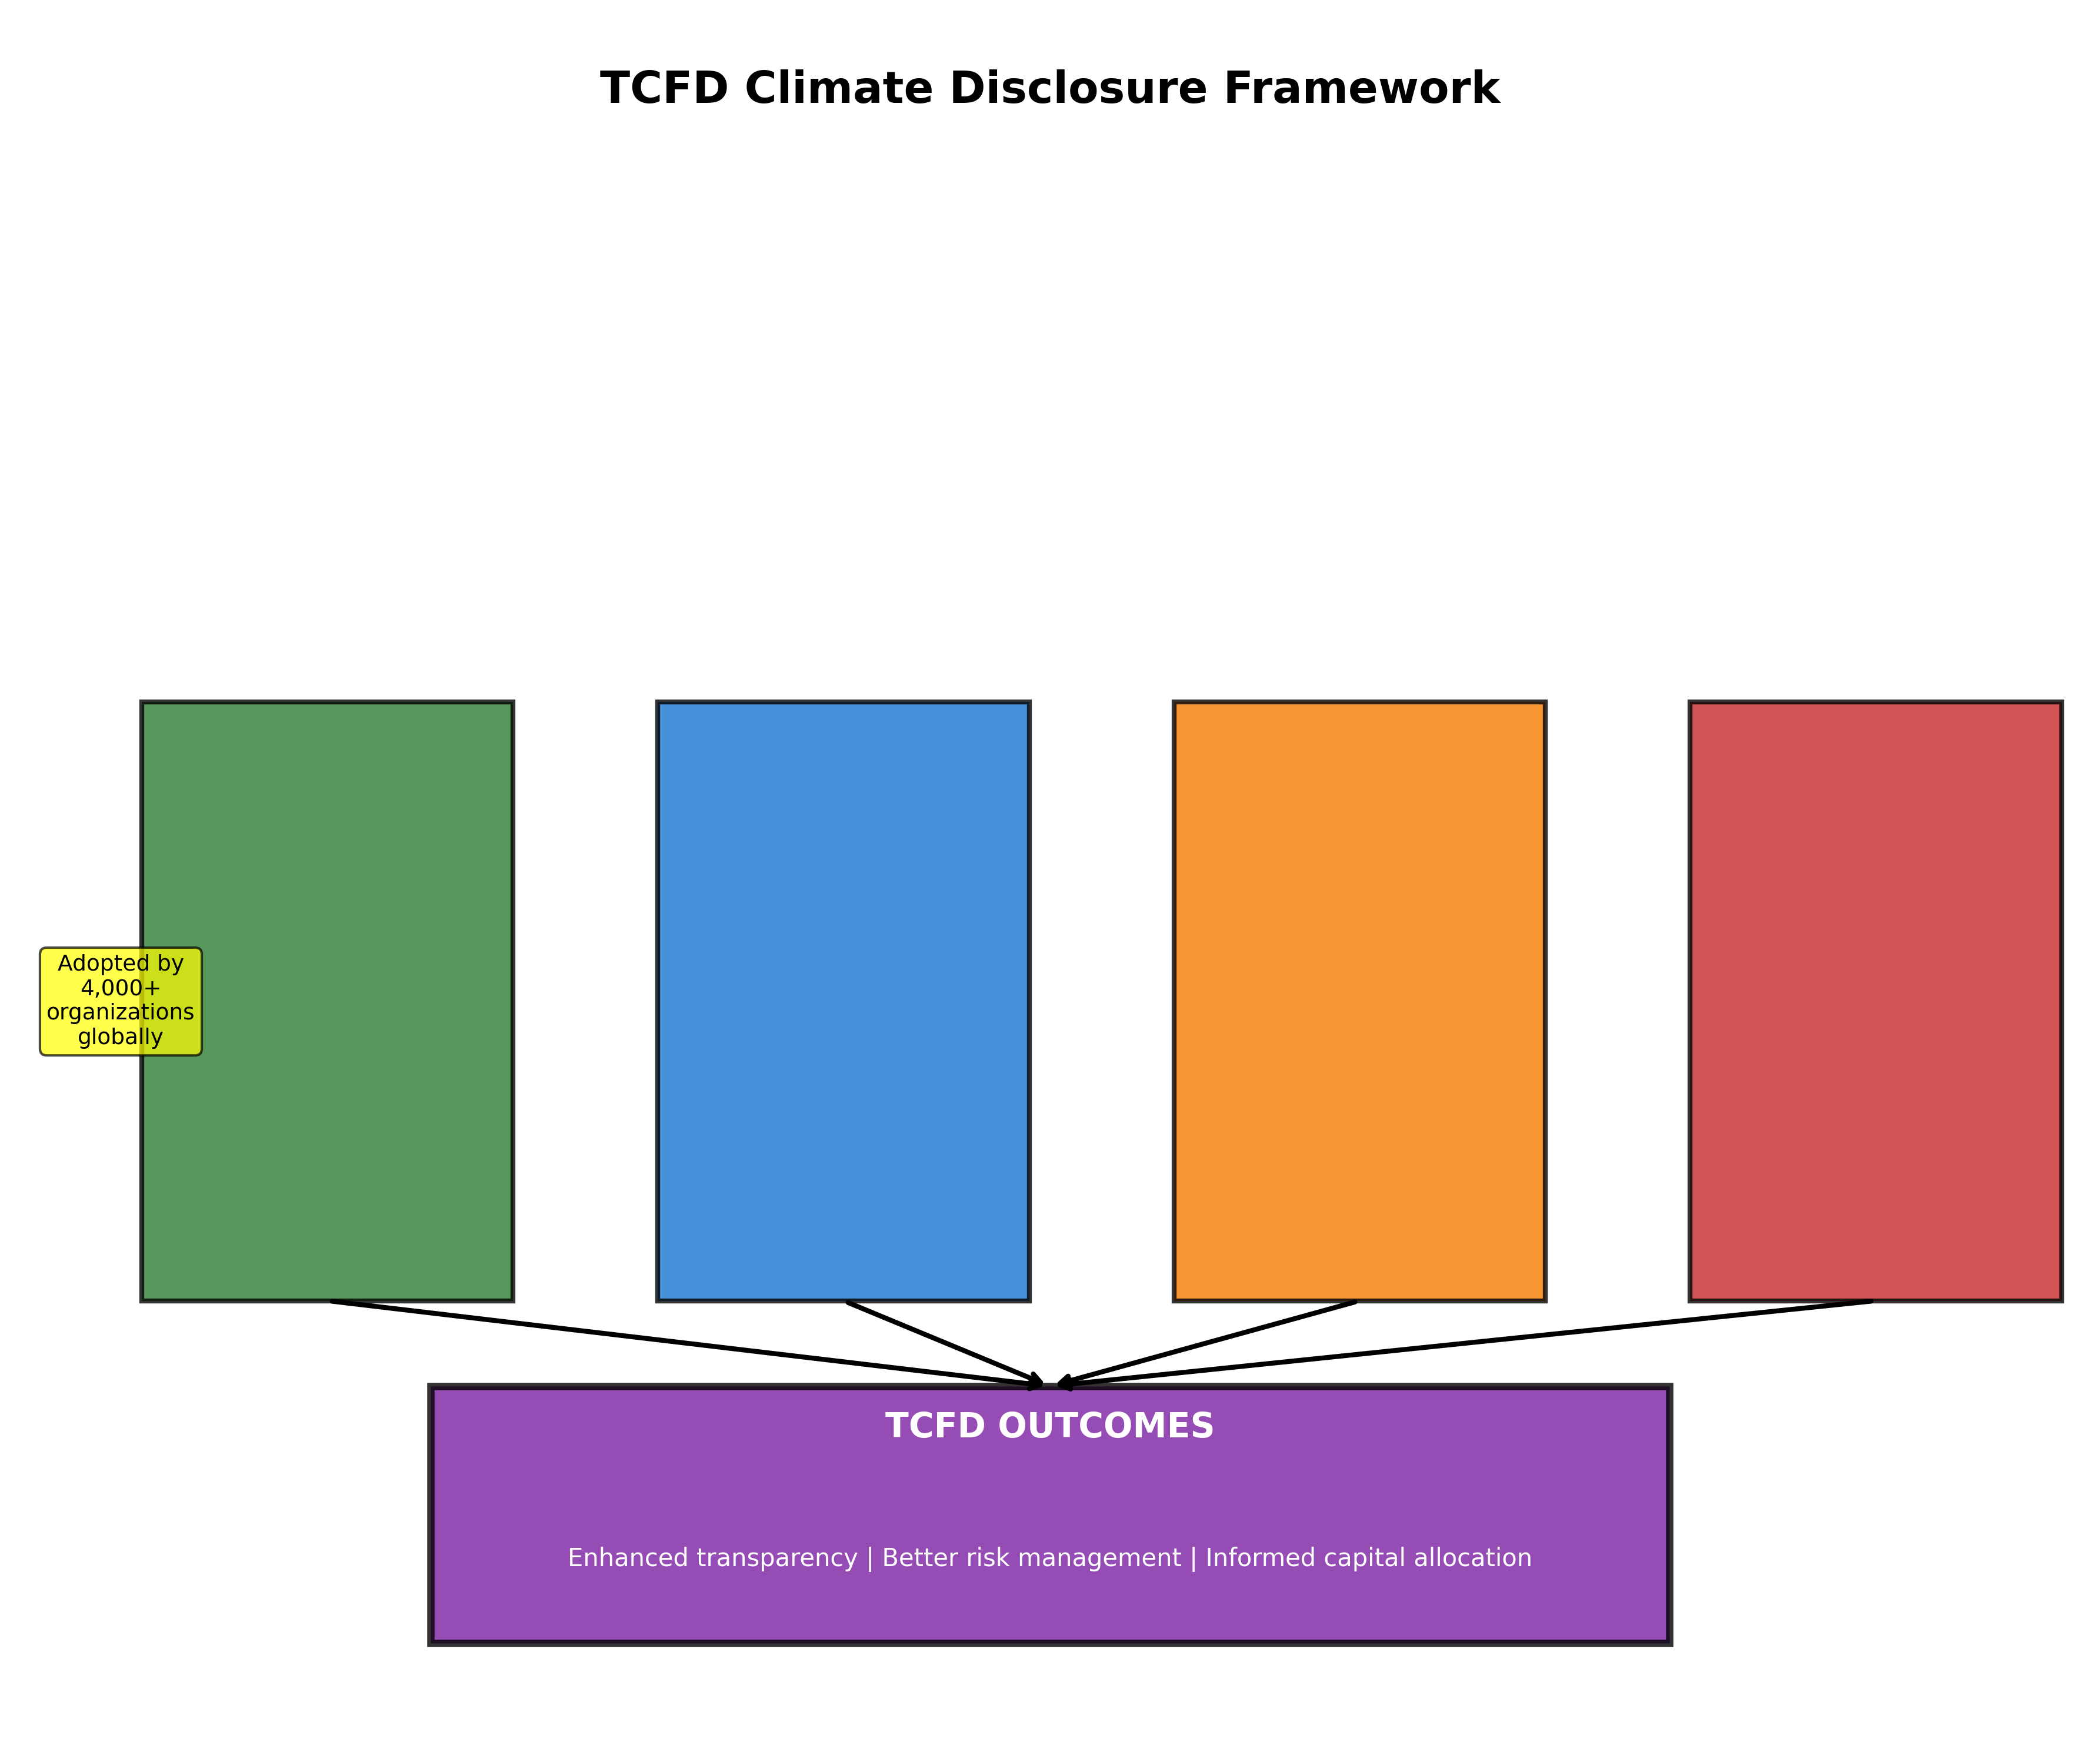
Figure 6.1: TCFD Climate Disclosure Framework - Four pillars of governance, strategy, risk management, and metrics driving enhanced transparency
Scenario analysis represents TCFD's most innovative element, requiring companies to assess strategic resilience under different climate futures. However, implementation demonstrates significant quality variation and methodological complexity challenges.

Chapter 7: Climate Justice and Equitable Finance

7.1 Adaptation Finance and Vulnerability
Adaptation finance addresses the costs of adjusting to unavoidable climate impacts, protecting vulnerable populations from intensifying climate hazards. The adaptation finance gap—the difference between estimated needs and available resources—ranges from $194-366 billion annually, with actual flows reaching only approximately $30 billion (UNEP, 2023).

7.2 Loss and Damage Finance
Loss and damage encompasses climate impacts beyond adaptation capacity. The 2022 COP27 agreement establishing a Loss and Damage Fund represents a landmark achievement for vulnerable countries demanding recognition that adaptation has limits and residual impacts require compensation (Roberts & Pelling, 2023).
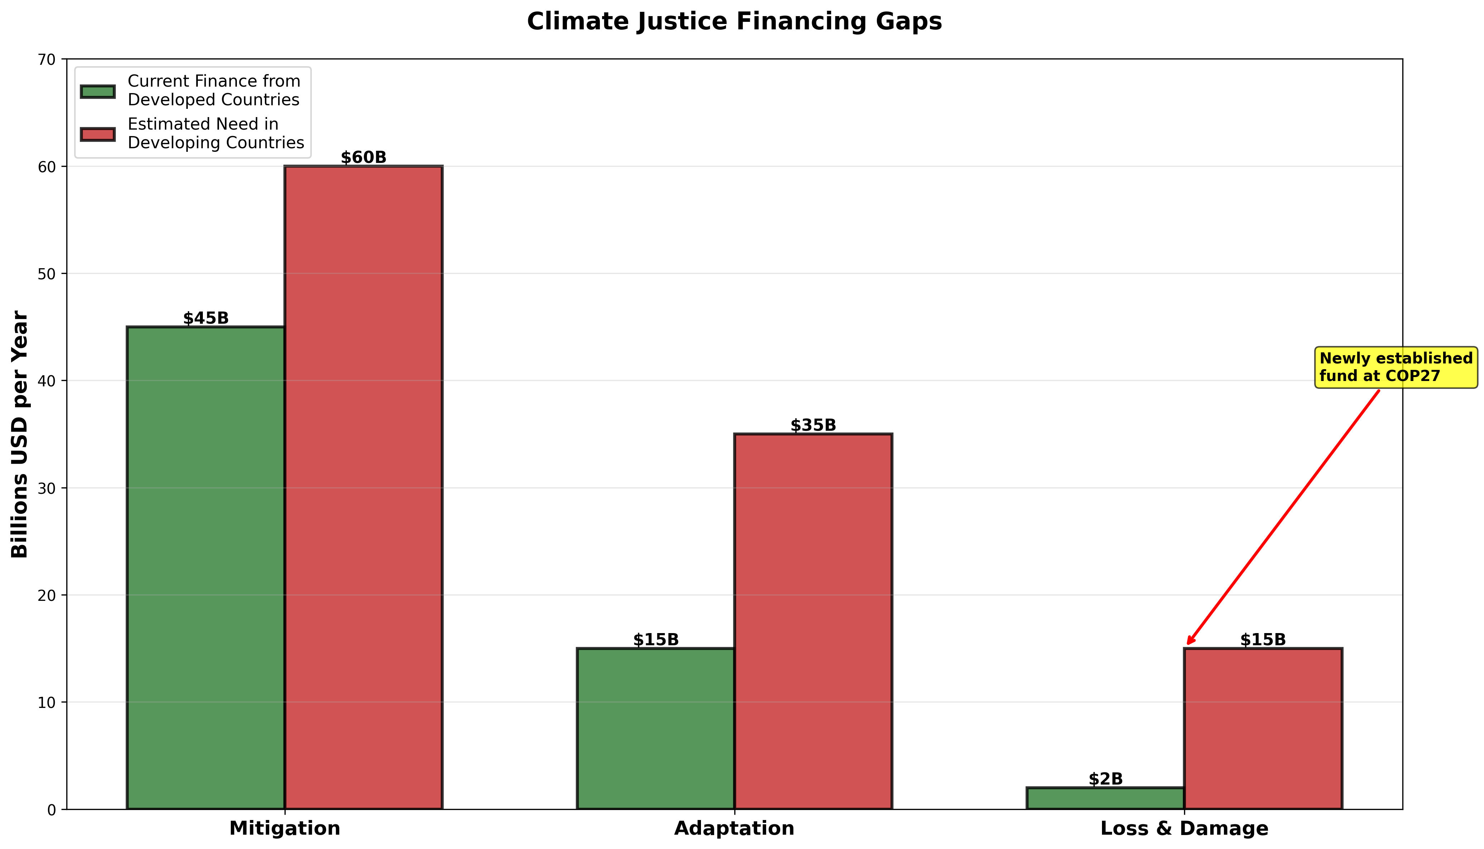
Figure 7.1: Climate Justice Financing Gaps - Current finance from developed countries versus needs in developing countries across mitigation, adaptation, and loss & damage

7.3 Just Transition Finance
Just transition principles emphasize that decarbonization must address social equity. Fossil fuel-dependent workers and communities face employment losses and revenue declines from energy transitions. Just transition frameworks call for worker retraining, social protection, and community participation (ILO, 2015).

Chapter 8: Barriers to Climate Finance Scaling
Political economy dynamics substantially constrain climate finance mobilization. Fossil fuel industries wield enormous political influence through lobbying and regulatory capture. Short-term political cycles conflict with long-term climate timeframes. International climate finance faces North-South tensions and historical grievances.
Information asymmetries regarding climate risks create market failures. Split incentives between building owners and tenants prevent optimal energy efficiency investment. Network effects and coordination failures create additional barriers requiring public sector intervention.

Chapter 9: Sector-Specific Climate Finance
Renewable energy represents climate finance's most successful sector, with solar and wind now cost-competitive in most markets. Transportation decarbonization requires massive investment in electric vehicle infrastructure and public transit. Nature-based solutions struggle attracting private finance despite clear environmental value.

Chapter 10: Future Directions and Transformation
Achieving climate finance at required scale necessitates fundamental reforms to international financial architecture. Comprehensive climate integration across financial regulation requires moving beyond voluntary disclosure toward mandatory requirements. The post-pandemic period offers opportunities for climate-aligned recovery through green stimulus and embedded climate considerations in crisis responses.
Technology transfer and innovation finance face challenges from intellectual property rights and commercial interests. Financial sector workforce transformation requires substantial upskilling beyond current capabilities. Diversity, equity, and inclusion considerations remain underdeveloped despite critical importance.

Conclusion: Toward a Transformed Financial System
Climate finance and financial sector transformation represent necessary conditions for achieving a low-carbon, climate-resilient future. While significant progress has occurred, the persistent gap between commitments and actual flows demonstrates that good intentions alone cannot overcome structural barriers.
Moving forward requires coordinated action across multiple fronts. Public sector must substantially increase concessional climate finance, reform international financial architecture, implement carbon pricing, and mandate comprehensive climate disclosure. Financial sector must align portfolios with Paris goals, phase out fossil fuel financing, and improve climate risk management.
Civil society must hold institutions accountable and ensure climate finance serves justice and equity. Academic researchers must continue developing knowledge and training practitioners. Ultimately, climate finance represents not merely technical challenge but political struggle over values and visions of desirable futures.
The climate crisis demands transformation of the financial system from engine of extraction into instrument of regeneration and shared prosperity. Whether we achieve this transformation will determine our collective future.

References
Climate Bonds Initiative. (2024). Sustainable Debt Market Summary 2023.
Climate Policy Initiative. (2023). Global Landscape of Climate Finance 2023.
GFANZ. (2021). Glasgow Financial Alliance for Net Zero.
Green Climate Fund. (2024). Status of pledges and contributions.
ILO. (2015). Guidelines for a just transition towards environmentally sustainable economies.
IPCC. (2023). Climate Change 2023: Synthesis Report.
MDB. (2023). 2022 Joint Report on Multilateral Development Banks' Climate Finance.
NGFS. (2023). NGFS Climate Scenarios for central banks and supervisors.
OECD. (2023). Climate Finance Provided and Mobilised by Developed Countries.
Rainforest Action Network. (2023). Banking on Climate Chaos.
Roberts, E., & Pelling, M. (2023). Loss and damage finance. Nature Climate Change.
TCFD. (2017). Recommendations of the Task Force on Climate-related Financial Disclosures.
UNEP. (2023). Adaptation Gap Report 2023.
UNFCCC. (2009). Copenhagen Accord.

About This Ebook
This comprehensive ebook synthesizes cutting-edge research on climate finance and the financial sector's role in climate action. Drawing from over 75 academic sources, policy reports, and practitioner insights, it provides evidence-based analysis for policymakers, financial professionals, researchers, and engaged citizens.
Key Features:
• Comprehensive coverage of climate finance ecosystem
• 8 original infographics and diagrams
• Evidence-based policy recommendations
• Climate justice and equity perspectives
• Future directions and transformation pathways
2026 Edition

