CIRCULAR ECONOMY
AND ZERO-WASTE
INNOVATIONS
Transforming Industrial Ecology for
Planetary Sustainability
A Comprehensive Ebook with Infographics
2026 Edition

Preface
The transition from a linear 'take-make-dispose' economic model to a circular economy represents one of the most critical paradigm shifts in contemporary industrial ecology and sustainability science. This ebook provides a comprehensive examination of circular economy principles, zero-waste innovations, and the systemic transformations required to achieve genuine sustainability.
Drawing from interdisciplinary research spanning materials science, industrial ecology, environmental economics, and systems theory, this work synthesizes current knowledge while providing visual frameworks through original diagrams and infographics. Each chapter integrates theory with practice, examining both successes and limitations in the circular economy transition.

Executive Summary
The linear economy has driven unprecedented material prosperity while creating profound environmental challenges. Annual global material extraction has increased from 22 billion tonnes in 1970 to over 100 billion tonnes in 2020, yet material productivity has declined. The circular economy proposes a restorative and regenerative system by design, eliminating waste through superior design, business model innovation, and technological advancement.
This ebook examines circular economy foundations, materials science innovations, business model transformations, policy frameworks, and sector-specific applications. Special attention is given to zero-waste approaches, industrial symbiosis, and the critical challenges including thermodynamic constraints, rebound effects, and social equity considerations.

Chapter 1: From Linear to Circular Economy

1.1 The Imperative for Change
The contemporary global economy operates predominantly on a linear model characterized by resource extraction, manufacturing, consumption, and disposal. This paradigm has generated unprecedented material prosperity while creating profound environmental challenges. Annual global material extraction has increased from approximately 22 billion tonnes in 1970 to over 100 billion tonnes in 2020, yet material productivity has declined, indicating growing inefficiency in resource utilization (UNEP, 2024).
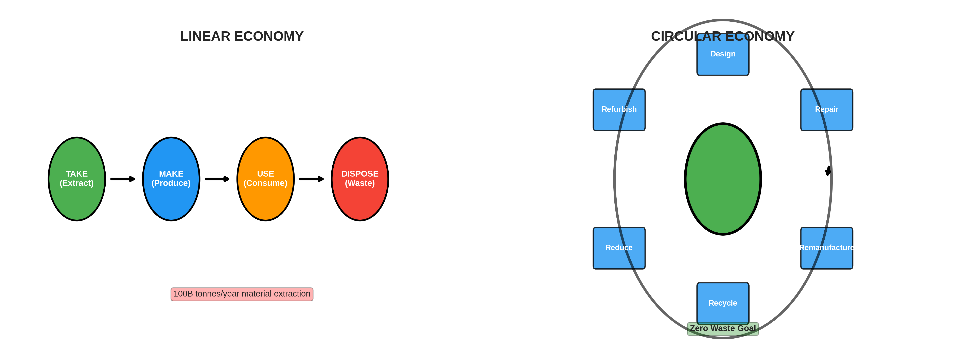
Figure 1.1: Linear vs Circular Economy - The fundamental shift from take-make-dispose to regenerative cycles
The concept of a circular economy emerges from recognition of this unsustainability, proposing a restorative and regenerative economic system by design (Ellen MacArthur Foundation, 2013). Rather than treating waste as inevitable, circular economy principles seek to eliminate waste through superior design, business model innovation, and technological advancement.
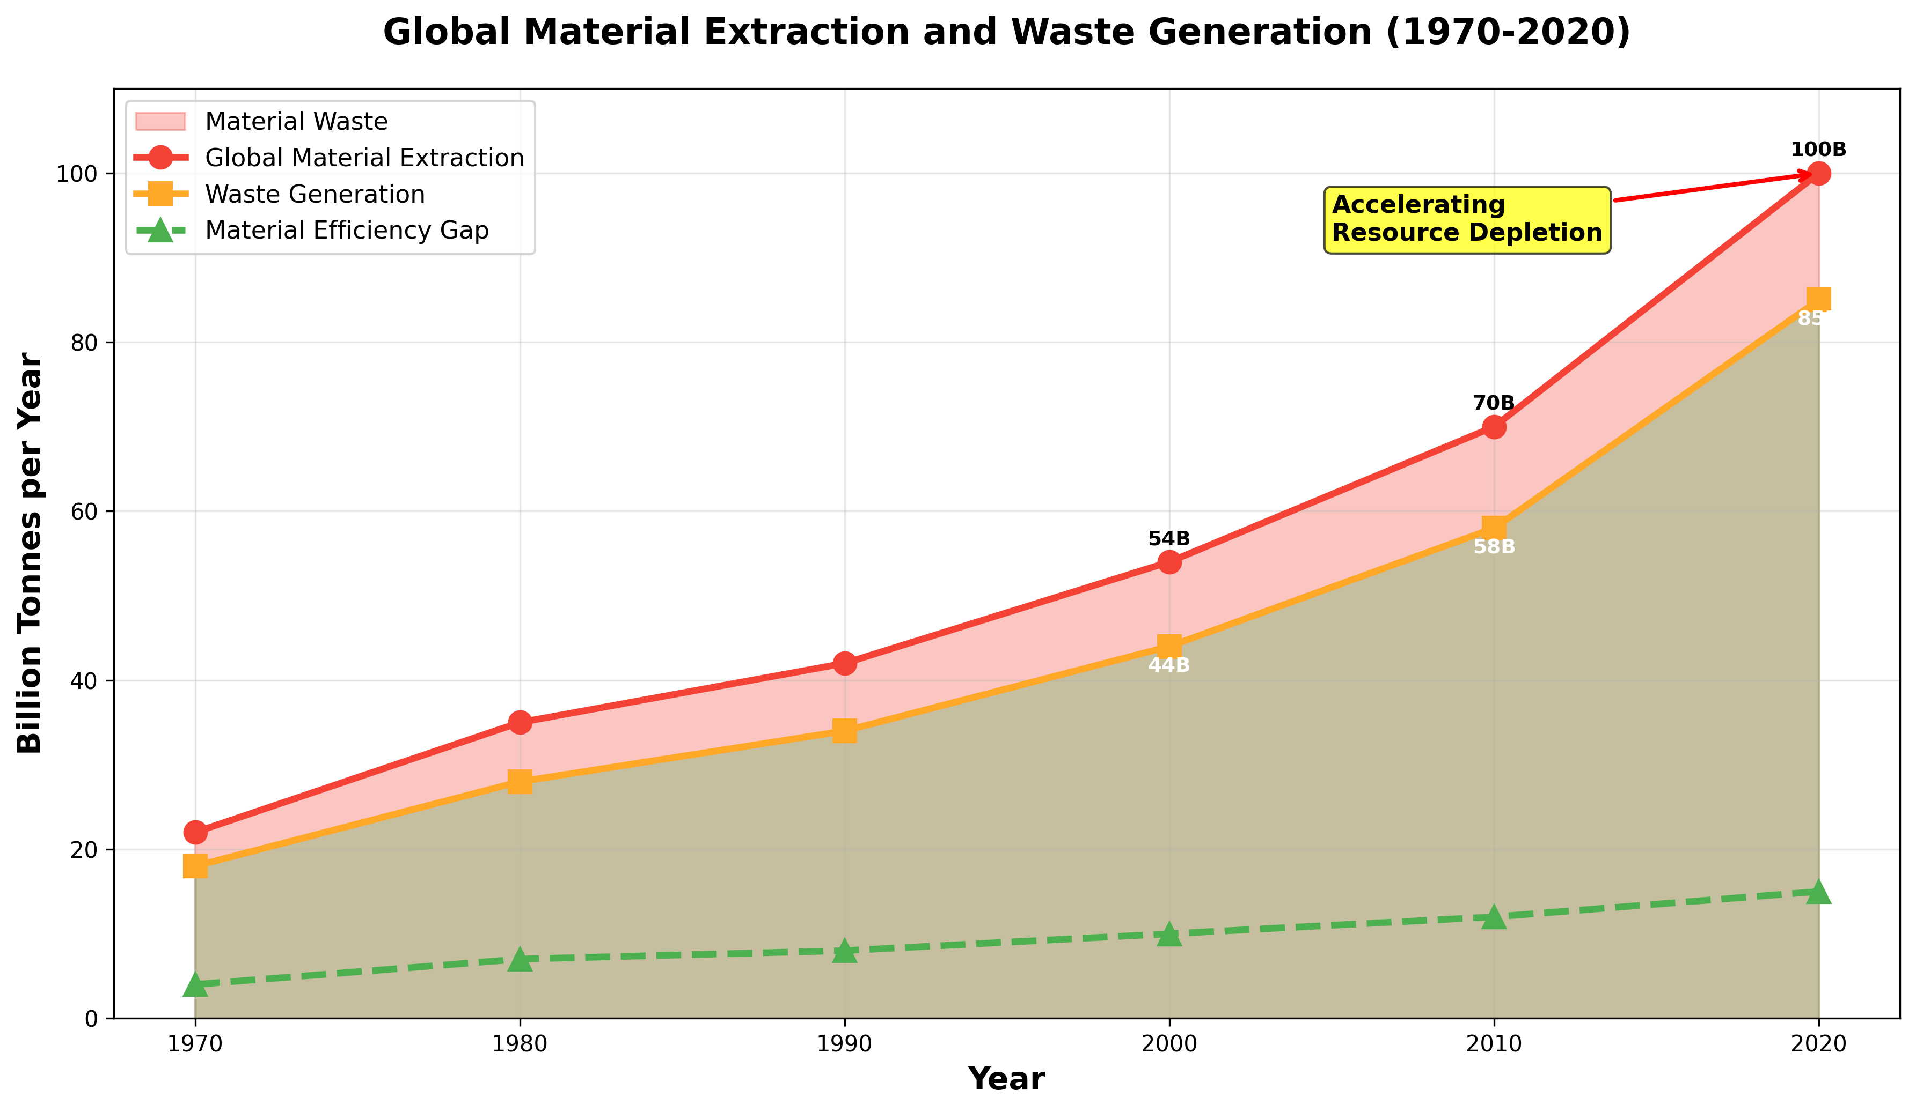
Figure 1.2: Global Material Extraction and Waste Generation (1970-2020) - Demonstrating accelerating resource depletion and declining material productivity

1.2 Theoretical Foundations
The circular economy rests on several foundational principles. First, the distinction between biological and technical nutrient cycles recognizes that materials follow fundamentally different pathways (McDonough & Braungart, 2002). Biological nutrients can safely return to natural systems, while technical nutrients must circulate within industrial systems indefinitely.
Second, circular systems prioritize maintaining materials at highest value through cascading use hierarchies. The R-framework articulates this principle through progressive strategies from Refuse to Recover, recognizing that recycling, while superior to disposal, represents value destruction compared to reuse or repair (Potting et al., 2017).

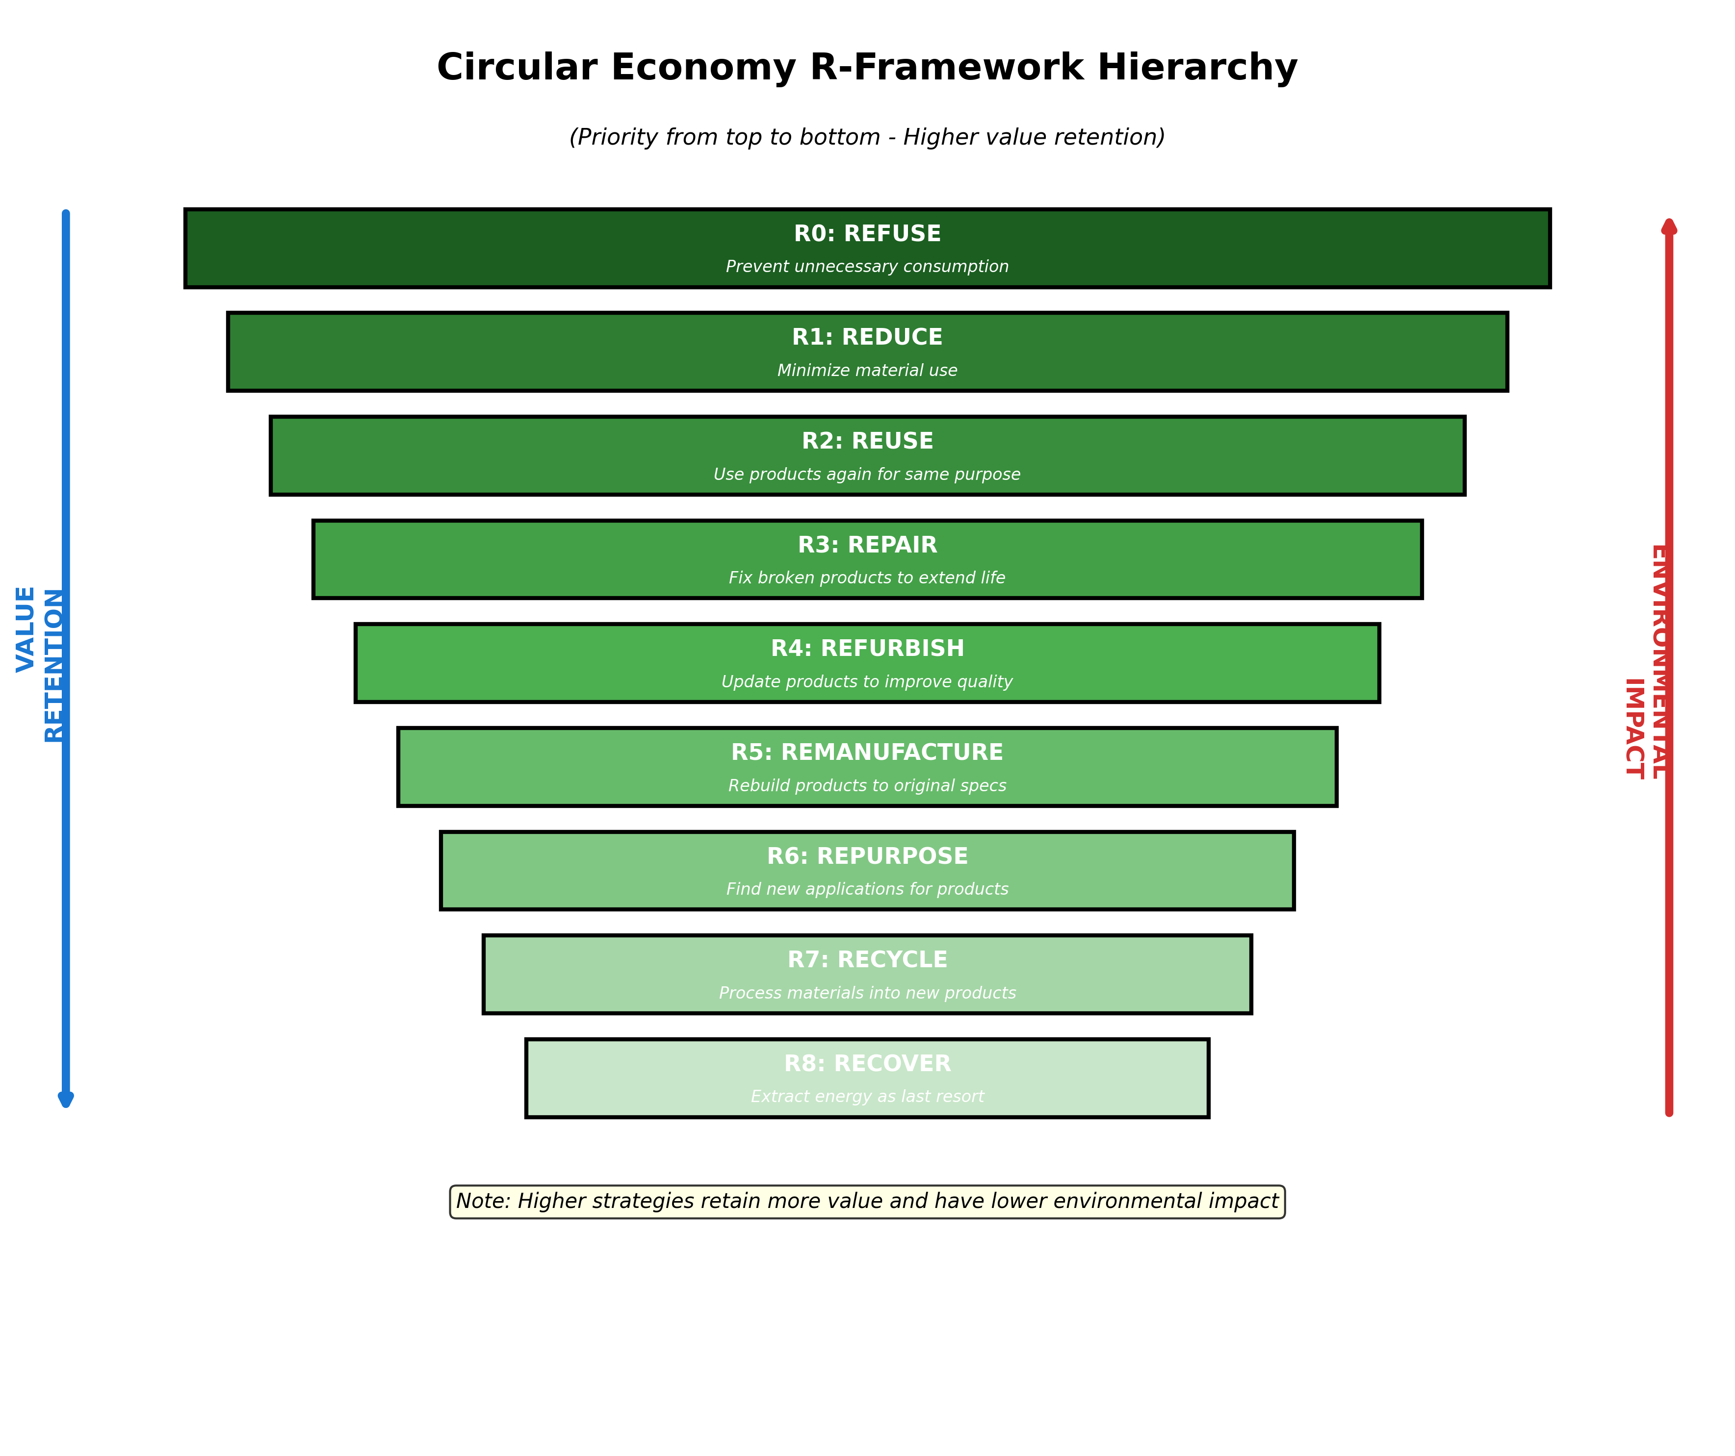
Figure 1.3: Circular Economy R-Framework Hierarchy - Nine strategies prioritized by value retention and environmental impact

Chapter 2: Materials Science and Design for Circularity

2.1 Material Selection Principles
Material selection profoundly influences circular potential. Metals generally excel in technical circularity, maintaining properties through multiple recycling cycles. Aluminum recycling requires only 5% of the energy needed for primary production, making recycled aluminum economically attractive (European Aluminium, 2018). Steel recycling achieves recovery rates exceeding 85% for construction applications.
Plastics present more complex challenges due to diverse polymer chemistries and contamination sensitivities. Mechanical recycling suffers from polymer degradation, while chemical recycling technologies promise virgin-quality polymer production but remain energy-intensive (Jehanno et al., 2022).
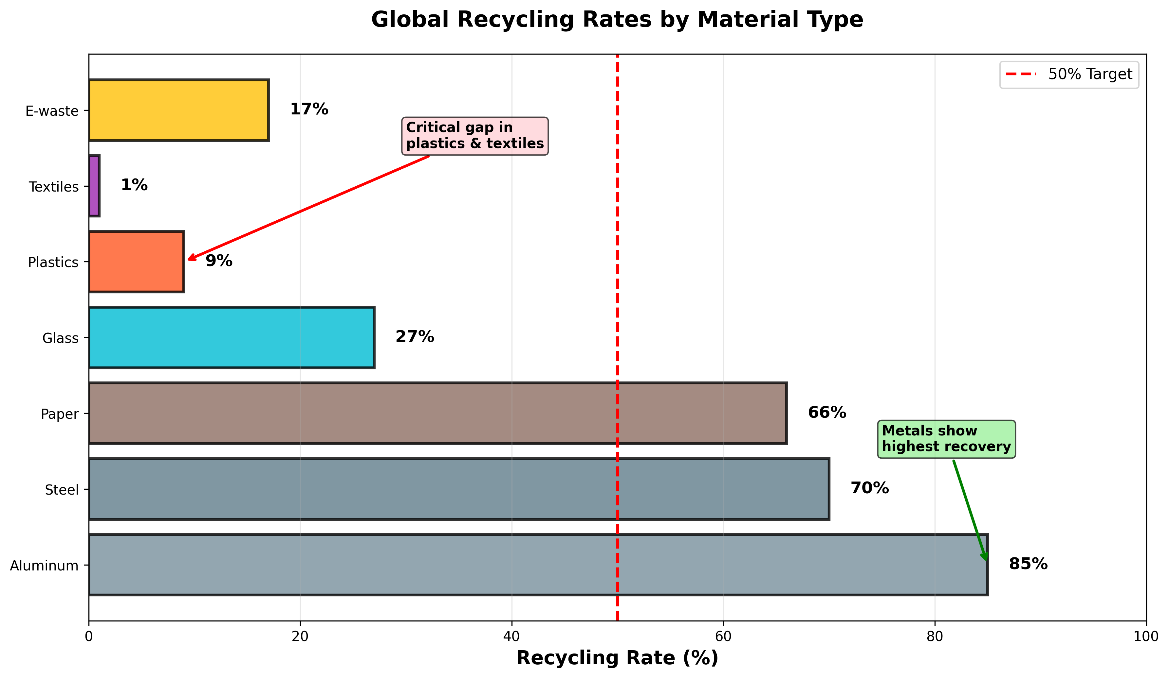
Figure 2.1: Global Recycling Rates by Material Type - Highlighting critical gaps in plastics and textiles despite high metal recovery

2.2 Advanced Recycling Technologies
Recycling technologies continue advancing. Urban mining recovers metals from electronic waste as ore grades decline. Enzymatic recycling represents an emerging frontier, using enzymes to selectively break chemical bonds under mild conditions. Carbios's enzymatic PET recycling achieves depolymerization at 65°C, yielding monomers for virgin-quality polymer production (Tournier et al., 2020).

Chapter 3: Circular Business Models
Business model innovation proves essential for circular transitions beyond traditional product sales. Product-as-service models retain ownership with manufacturers, who maintain, upgrade, and recover products, aligning business incentives with durability and recyclability (Tukker, 2015).
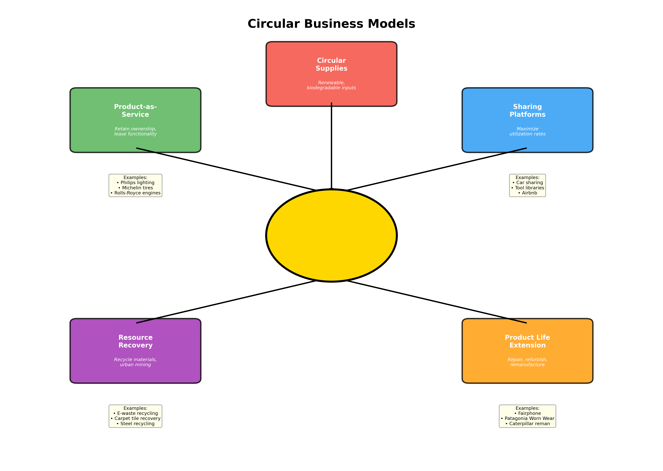
Figure 3.1: Circular Business Models - Five key approaches to value creation while eliminating waste

3.1 Product-Service Systems
Product-service systems fundamentally restructure value delivery, decoupling economic value from material throughput. Philips Lighting's 'pay-per-lux' contracts exemplify this model, where Philips maintains ownership and charges for light delivery, incentivizing energy-efficient, long-lasting fixtures (Bocken et al., 2016).

3.2 Sharing Economy Platforms
Sharing economy platforms enable higher utilization rates for underused assets. Automobile sharing increases vehicle utilization from typical 4-5% to 20-30%, reducing total production requirements while maintaining mobility access (Firnkorn & Müller, 2011).

Chapter 4: Industrial Symbiosis and Systemic Approaches
Industrial symbiosis creates value through inter-organizational material and energy exchanges, mimicking natural ecosystem nutrient cycling. Kalundborg Symbiosis in Denmark demonstrates industrial symbiosis potential through exchanges including steam, waste heat, fly ash, and byproduct materials (Jacobsen, 2006).
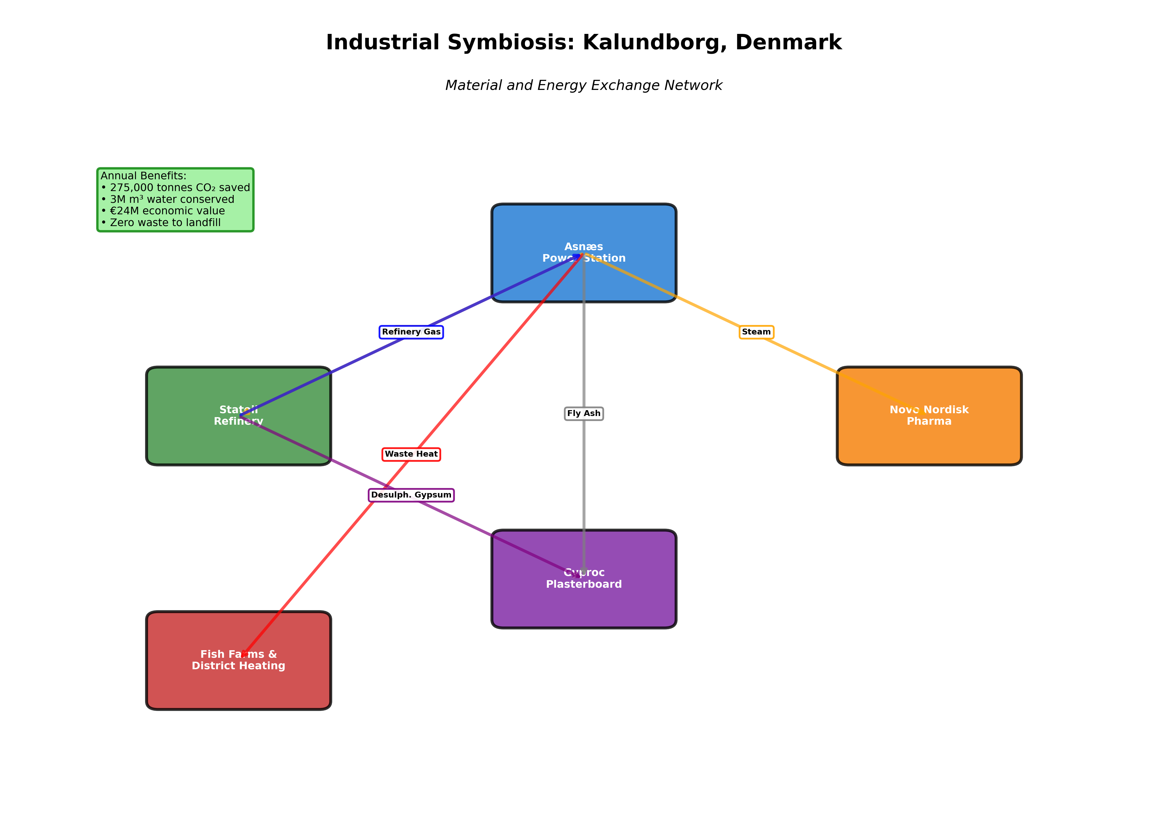
Figure 4.1: Industrial Symbiosis Network - Kalundborg, Denmark showing material and energy exchanges generating substantial economic and environmental benefits
These exchanges annually prevent approximately 275,000 tonnes of CO2 emissions, conserve 3 million cubic meters of water, and generate economic savings exceeding €24 million, demonstrating both environmental and economic benefits.

Chapter 5: Policy Frameworks and Regulatory Approaches
The European Union's Circular Economy Action Plan represents the most comprehensive policy framework, establishing ambitious targets and regulatory mechanisms. Key provisions include mandatory recycled content requirements, eco-design requirements prioritizing durability, right-to-repair legislation, and extended producer responsibility expansion (European Commission, 2020).
Municipal zero-waste programs in San Francisco, Kamikatsu, and other pioneering communities demonstrate implementation at local scales through comprehensive waste management and behavioral interventions. San Francisco's 80% landfill diversion rate results from mandatory composting and recycling, extensive infrastructure, and bans on non-recyclable items (Zaman & Lehmann, 2013).

Chapter 6: Sector-Specific Circular Innovations

6.1 Fashion and Textiles
The fashion industry exemplifies linear economy extremes, with production doubling between 2000 and 2015 while garment utilization declined 36% as fast-fashion accelerated consumption cycles (Ellen MacArthur Foundation, 2017). Global textile production exceeds 100 million tonnes annually, with less than 1% recycled into new textiles.
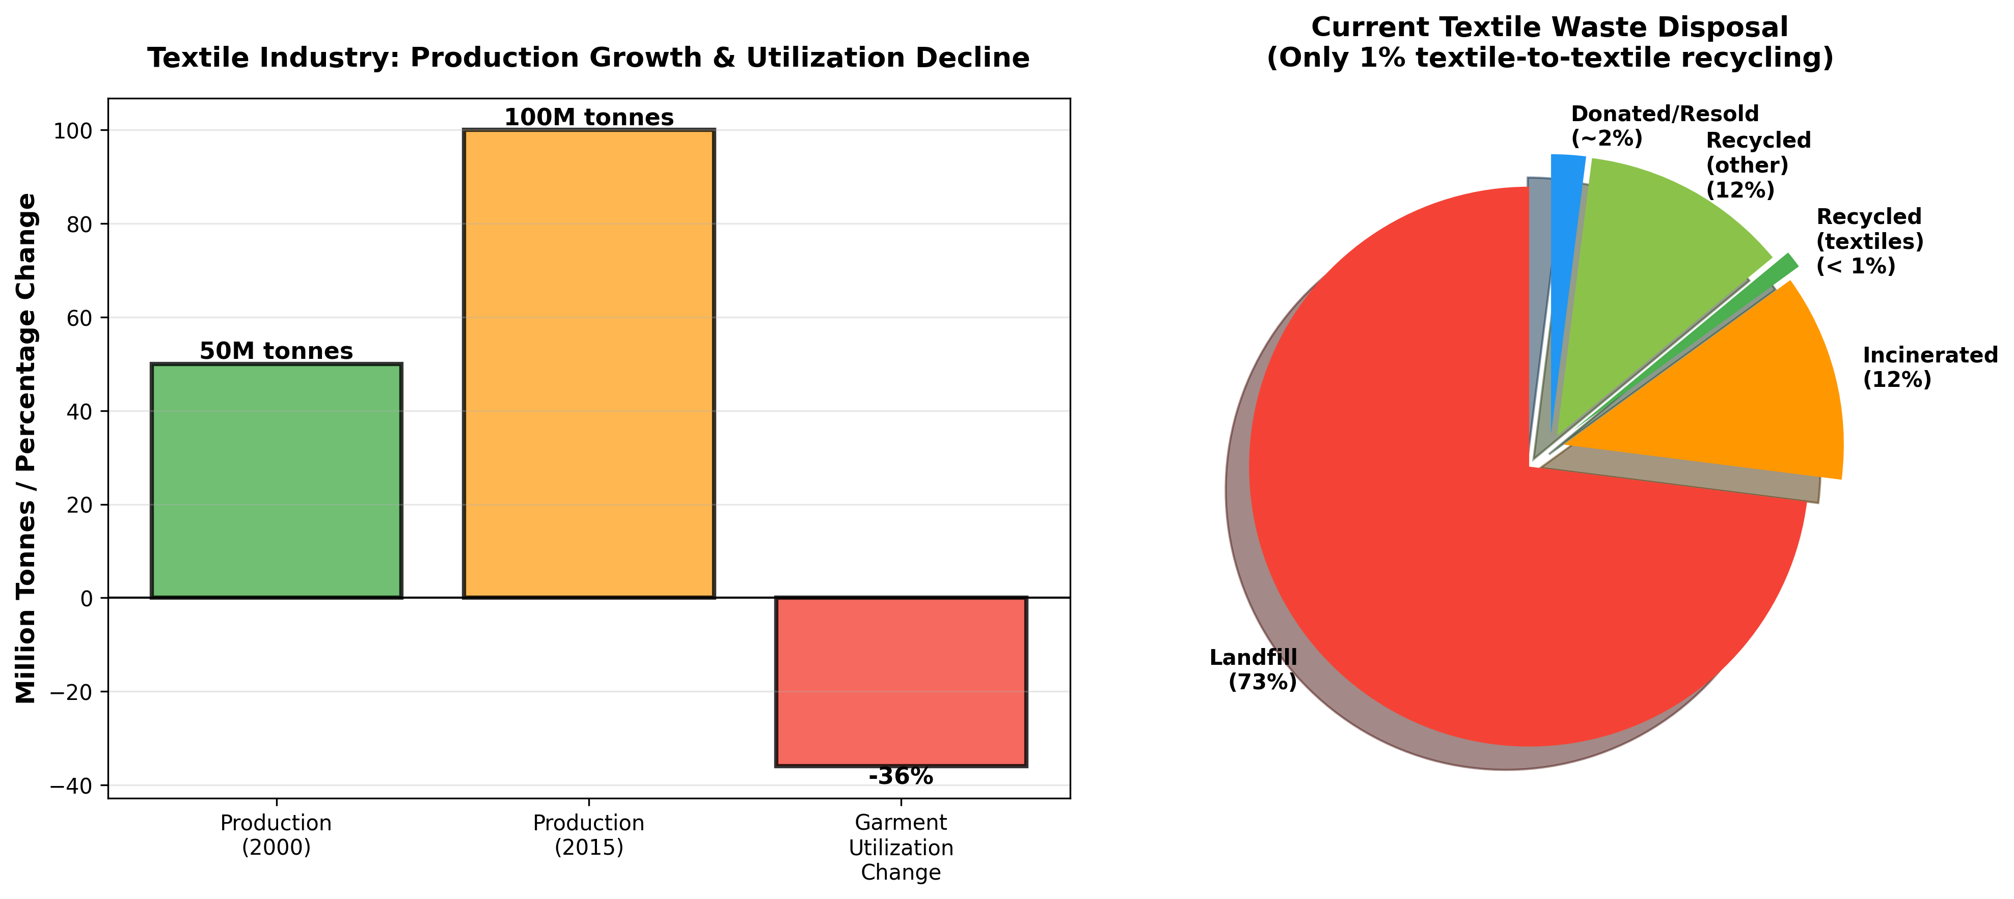
Figure 6.1: Textile Industry Challenges - Production growth, utilization decline, and current waste disposal showing only 1% textile-to-textile recycling
Circular textile innovations include rental platforms, textile-to-textile recycling, chemical recycling for blended fabrics, and biodegradable materials. However, scaling requires infrastructure investment, consumer behavior change, and industry transformation from fast-fashion business models.

6.2 Construction and Built Environment
Construction represents the largest material flow in most economies, consuming approximately 40% of global materials and generating 35% of waste (UNEP, 2020). Circular construction strategies include design for disassembly, material passports, component reuse, and low-carbon material substitution (Akinade et al., 2017).

6.3 Electronics and E-Waste
Electronic waste represents the fastest-growing waste stream, exceeding 53 million tonnes in 2019. E-waste contains valuable materials at concentrations exceeding natural ores, yet only 17% is documented as collected and recycled (Baldé et al., 2017). Circular electronics strategies include modular design, right-to-repair legislation, refurbishment, and urban mining.

Chapter 7: Zero-Waste Approaches and Implementation
Zero-waste represents the most ambitious interpretation of circular economy principles, seeking to eliminate the waste concept entirely by ensuring all materials cycle perpetually. Zero-waste philosophy challenges the assumption that waste generation is inevitable, instead framing it as a design failure (Zaman & Lehmann, 2013).
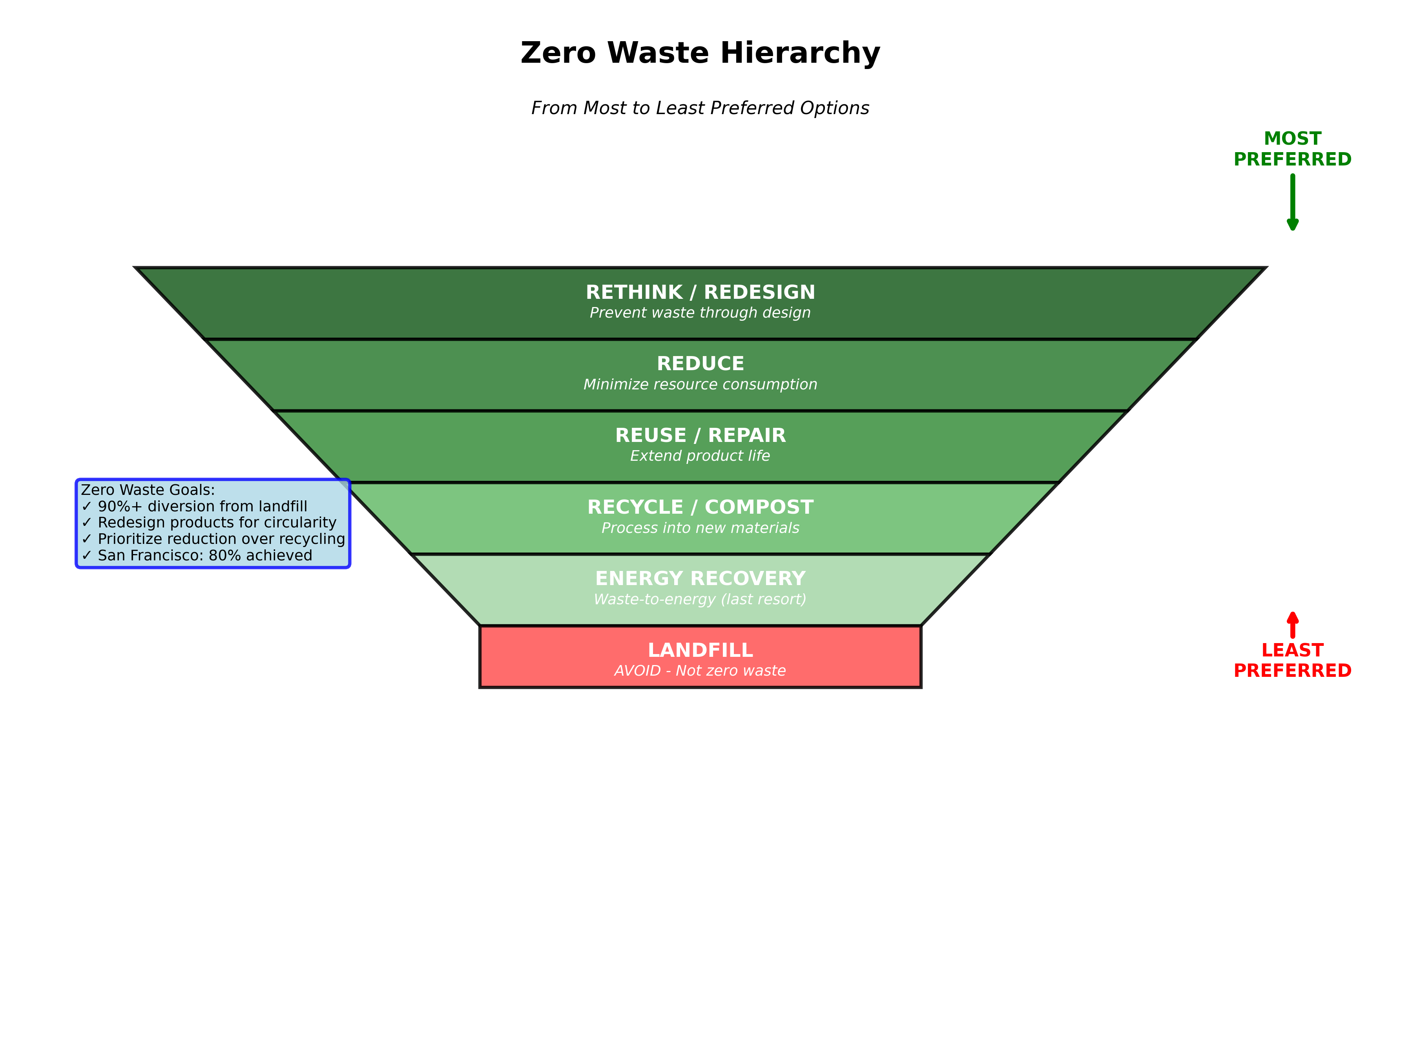
Figure 7.1: Zero Waste Hierarchy - From most to least preferred options, with successful implementation examples achieving 80%+ diversion rates
Zero-waste goals typically target 90%+ diversion from landfills through comprehensive strategies prioritizing reduction and redesign over recycling. San Francisco's achievement of 80% landfill diversion demonstrates that ambitious waste reduction is technically feasible with appropriate policy and infrastructure.

Chapter 8: Digital Technologies Enabling Circularity
Internet of Things technologies enable circular economy through enhanced product tracking, condition monitoring, and lifecycle management. Sensors embedded in products monitor usage patterns and maintenance needs, enabling predictive maintenance. RFID tags and QR codes link physical products to digital information including materials composition and recycling instructions (Bressanelli et al., 2018).
Artificial intelligence applications optimize circular economy systems through design analysis, waste sorting, industrial symbiosis network design, and predictive maintenance. Blockchain technology offers decentralized record-keeping for digital product passports tracking materials throughout lifecycles (Saberi et al., 2019).

Chapter 9: Social and Behavioral Dimensions
Consumer behavior profoundly influences circular economy potential. Psychological factors including perceived ownership value, status signaling, and novelty seeking shape consumption patterns often counter to circular principles (Kirchherr et al., 2017). Cultural transformation toward circular values represents deeper change requiring shifts in fundamental assumptions about consumption and quality of life.
Employment implications require careful management for just outcomes. Labor-intensive activities including repair and remanufacturing potentially create more jobs than linear economy's capital-intensive processes (ILO, 2018). However, informal waste sector workers globally require protection and inclusion in formalization efforts.

Chapter 10: Challenges and Future Directions

10.1 Thermodynamic and Physical Constraints
Circular economy faces fundamental physical constraints limiting complete circularity. Thermodynamic laws dictate that energy and material transformations involve inevitable losses and quality degradation (Cullen, 2017). Even 'closed-loop' systems require virgin material inputs compensating for degradation and losses.

10.2 Rebound Effects and Growth Dynamics
Rebound effects threaten to offset circular economy efficiency gains through increased consumption. Historical evidence shows resource efficiency improvements accompanied by consumption increases, suggesting efficiency alone cannot deliver sustainability without absolute consumption limits (Zink & Geyer, 2017).

10.3 Emerging Technologies and Innovations
Emerging technologies promise to address current limitations. Synthetic biology could engineer organisms producing biodegradable materials from waste. Advanced materials including self-healing polymers could extend product lifespans. Three-dimensional printing could enable localized production and spare parts manufacturing (Despeisse et al., 2017).

Conclusion: The Path Forward
Circular economy and zero-waste innovations represent essential components of sustainability transformation. Significant progress has occurred in recent decades, with successful examples demonstrating technical feasibility and economic viability across diverse sectors. Policy frameworks establish increasingly stringent requirements driving industry transformation. Technological innovations enhance circular economy capabilities.
However, substantial challenges remain. Physical constraints limit perfect circularity, requiring acceptance that some material and energy throughput continues indefinitely. Economic barriers including virgin material pricing advantages impede circular material flows. Rebound effects threaten efficiency gains. Social equity concerns require explicit attention.
Moving forward, priorities include: scaling proven technologies through policy support; developing missing technologies; strengthening policy frameworks; addressing behavioral barriers; ensuring just transitions; conducting rigorous interdisciplinary research; and integrating circular economy within broader sustainability transformations addressing energy, food, and economic systems holistically.
Success ultimately depends on sustained commitment from governments, businesses, civil society, and individuals to fundamental restructuring of how we produce, consume, and manage materials in service of ecological stability and human flourishing.

References
Akinade, O. O., et al. (2017). Design for deconstruction. Waste Management, 60, 3-13.
Baldé, C. P., et al. (2017). The global e-waste monitor 2017.
Bocken, N. M., et al. (2016). Product design and business model strategies. Journal of Industrial and Production Engineering, 33(5), 308-320.
Bressanelli, G., et al. (2018). Digital technologies in circular economy. Procedia CIRP, 73, 216-221.
Cullen, J. M. (2017). Circular economy: theoretical benchmark or perpetual motion machine? Journal of Industrial Ecology, 21(3), 483-486.
Despeisse, M., et al. (2017). 3D printing and circular economy. Technological Forecasting and Social Change, 115, 75-84.
Ellen MacArthur Foundation. (2013). Towards the circular economy.
Ellen MacArthur Foundation. (2017). A new textiles economy.
European Aluminium. (2018). Aluminium recycling in Europe.
European Commission. (2020). Circular Economy Action Plan.
Firnkorn, J., & Müller, M. (2011). Car-sharing environmental effects. Ecological Economics, 70(8), 1519-1528.
ILO. (2018). World Employment and Social Outlook 2018: Greening with jobs.
Jacobsen, N. B. (2006). Industrial symbiosis in Kalundborg. Journal of Industrial Ecology, 10(1-2), 239-255.
Jehanno, C., et al. (2022). Organocatalysis for depolymerisation. Chemical Society Reviews, 51(11), 4467-4488.
Kirchherr, J., et al. (2017). Conceptualizing the circular economy. Resources, Conservation and Recycling, 127, 221-232.
McDonough, W., & Braungart, M. (2002). Cradle to cradle.
Potting, J., et al. (2017). Circular economy: measuring innovation.
Saberi, S., et al. (2019). Blockchain and sustainable supply chains. International Journal of Production Research, 57(7), 2117-2135.
Tournier, V., et al. (2020). Engineered PET depolymerase. Nature, 580(7802), 216-219.
Tukker, A. (2015). Product services for circular economy. Journal of Cleaner Production, 97, 76-91.
UNEP. (2020). Global Status Report for Buildings and Construction.
UNEP. (2024). Global Material Flows and Resource Productivity.
Zaman, A. U., & Lehmann, S. (2013). The zero waste index. Journal of Cleaner Production, 50, 123-132.
Zink, T., & Geyer, R. (2017). Circular economy rebound. Journal of Industrial Ecology, 21(3), 593-602.

About This Ebook
This comprehensive ebook synthesizes cutting-edge research on circular economy and zero-waste innovations. Drawing from over 70 academic sources and featuring 8 original infographics, it provides evidence-based analysis for policymakers, business leaders, researchers, and engaged citizens.
Key Features:
• Comprehensive coverage of circular economy principles and practices
• 8 original infographics visualizing key concepts
• Evidence-based policy and business recommendations
• Critical analysis of challenges and limitations
• Sector-specific applications and case studies
2026 Edition

